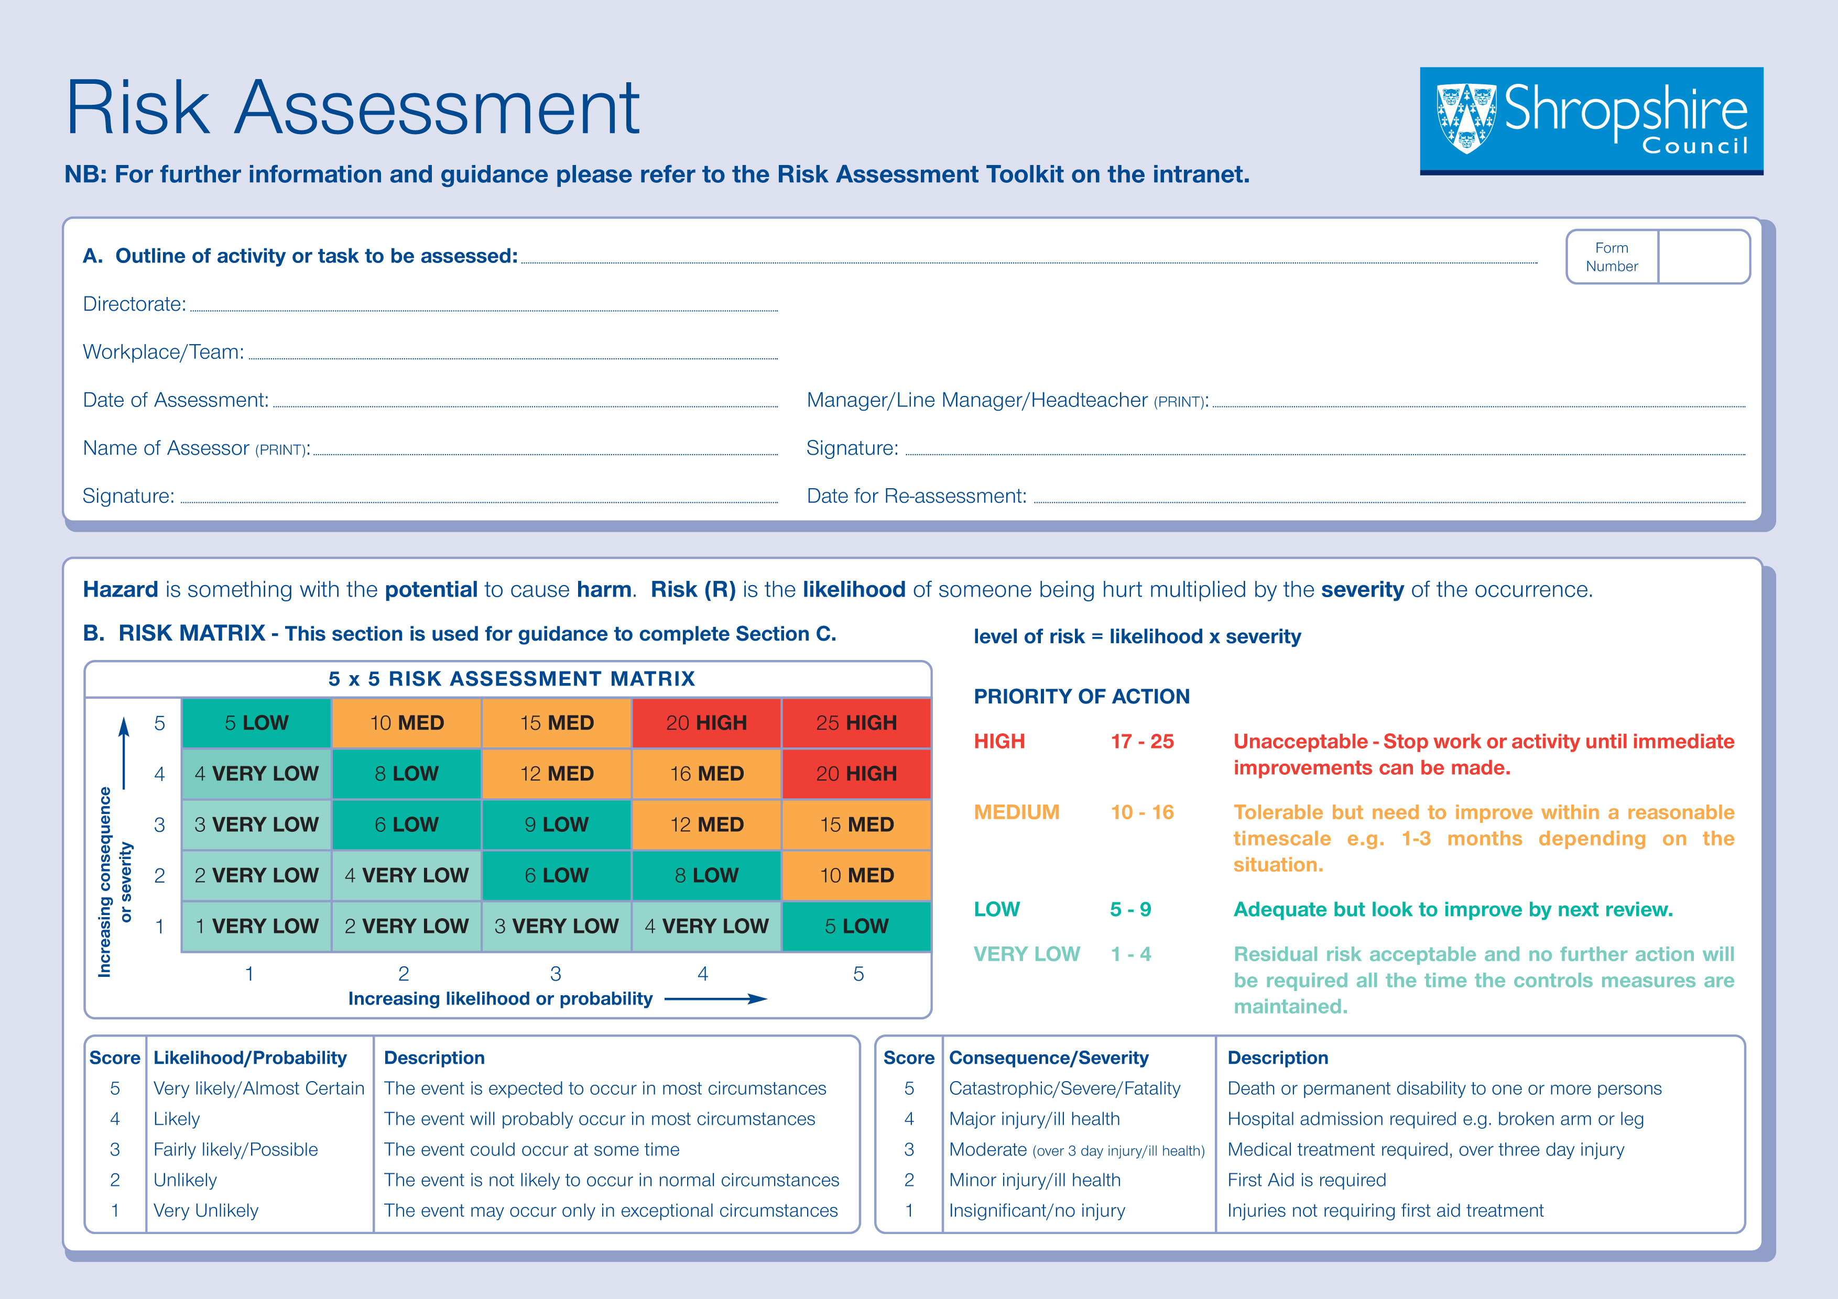

Sun Protection
CYPS
May 2015
Annual (or when any major changes occur).

C. Use information from section B to identify level of risk for each hazard
What are the  Hazards? |  | Who might be harmed and how the hazard could cause harm | What are you already doing?  (Existing Controls)  Adapt for your own circumstances | Risk  Level  Low/  Med/  High | What further actions  are necessary | Residual Risk  Level  Low/Med/  High | Action
 |  |  |  |  |  |  | Who | When
1 | Sun Burn,  Heat exhaustion  Radiation exposure | Employees, Pupils, Service users, Volunteers | Policy  - Sun protection procedures are incorporated in Health and Safety Policy.
1 | Sun Burn,  Heat exhaustion  Radiation exposure | Employees, Pupils, Service users, Volunteers | - Staff are trained/instructed in the importance of using sun protection.
1 | Sun Burn,  Heat exhaustion  Radiation exposure | Employees, Pupils, Service users, Volunteers | - Protection against the sun is actively promoted to pupils in other ways e.g. assemblies, workshops, talks.
1 | Sun Burn,  Heat exhaustion  Radiation exposure | Employees, Pupils, Service users, Volunteers | - Pupils are encouraged to wear suitable clothing e.g. long sleeves tops, hats etc.
1 | Sun Burn,  Heat exhaustion  Radiation exposure | Employees, Pupils, Service users, Volunteers | - Parents are informed of the importance of sun protection and the School’s policy (e.g. via letter, website and newsletter).
1 | Sun Burn,  Heat exhaustion  Radiation exposure | Employees, Pupils, Service users, Volunteers | - Ensure there is plenty of fresh drinking water available and children are encouraged to drink regularly.
1 | Sun Burn,  Heat exhaustion  Radiation exposure | Employees, Pupils, Service users, Volunteers | - Sun protection is considered when off-site and is included in the visit risk assessments.
1 | Sun Burn,  Heat exhaustion  Radiation exposure | Employees, Pupils, Service users, Volunteers | Shade  - Trees have been planted to provide long-term shade on the School site.
1 | Sun Burn,  Heat exhaustion  Radiation exposure | Employees, Pupils, Service users, Volunteers | - Shade structures provide long/short term shade.
1 | Sun Burn,  Heat exhaustion  Radiation exposure | Employees, Pupils, Service users, Volunteers | - Organised activities make use of the shade available.
1 | Sun Burn,  Heat exhaustion  Radiation exposure | Employees, Pupils, Service users, Volunteers | - Seats and equipment are moved to shady areas.
1 | Sun Burn,  Heat exhaustion  Radiation exposure | Employees, Pupils, Service users, Volunteers | Timetabling  - Outdoor activities and events are planned  outside of 11 am – 3 pm where possible
1 | Sun Burn,  Heat exhaustion  Radiation exposure | Employees, Pupils, Service users, Volunteers | - In the summer term morning break is extended and lunch breaks shortened to avoid the midday sun.

Clothing
- Pupils are encouraged to wear wide-brimmed (or legionnaire style) hats when outside.
 |  |  | - Pupils are encouraged to wear tops that cover their shoulders (vests and strappy tops are discouraged).
 |  |  | - School uniform tops and hats offer suitable sun protection.
 |  |  | - Pupils are allowed to wear UV protective sunglasses.
 |  |  | - Teachers and assistants also wear suitable hats and clothing.
Sunscreen
- Pupils are allowed to bring in their own personal supply of sunscreen.
 |  |  | - There is a school stock of sunscreen for pupils who forget/cannot afford their own. (Parental consent has been obtained and School notified of any allergies)
- High Protection Factor Sunscreen (SPF15 and
4 stars minimum) is used.
 |  |  | - Pupils are supervised applying their own sunscreen. Most pupils will be able to, with some direction, to apply sunscreens themselves. Self-application is recommended. Spray sunscreens may be easier to be applied by the pupil.
- Young children and some children with special needs may require assistance. Written permission must be gained from parents and carers for staff to apply sunscreen. Teachers and support staff that apply sunscreens should do so to the face, neck and arms in accordance with relevant school policies to minimise the risk of abuse allegations.
- Teachers remind pupils to reapply sunscreen regularly, particularly at midday.
List any additional foreseeable hazards |  |  | At least SPF 15 sunscreen is used in school and is applied generously and regularly.
SUNSCREEN
N.B. Sunscreen is the last line of defence, but it is useful for protecting areas of skin that cannot be covered up. SUNSCREEN
- There is no legislation that prevents teachers and support staff from administering sunscreens
- but this must be on a purely voluntary basis. Teachers must use their professional judgement to decide.
See http://www.cancerresearchuk.org/health-professional/prevention-and-awareness/sunsmart/sun-safety-at-schools for further information and best practice

D. Safe Systems of Work to be outlined below by using the information in Section C once completed:

- Health and Safety Policy incorporating arrangements in place for Sun Protection including appropriate clothing to be worn and application of sun creams. E.g. Sunscreen should be used for covering exposed areas of skin when shade may be unavailable and protective clothing is not practical e.g. during outdoor swimming, PE lessons and school excursions. Choose a sunscreen with an SPF of at least 15 which is also labelled broad spectrum to protect from UVA and UVB rays and ensure that sunscreen is applied regularly and generously. For the average person, this means two teaspoonfuls for the head, arms and neck or two tablespoonfuls if in a swimming costume.
- Robust implementation of procedures. Records kept e.g. of minutes of meetings.
- Training and instruction for staff, parents and pupils. Records kept.
- Planning outside activities to minimise sun exposure identified in risk assessment.



