
Unit4 ERP User Guide
ERP Purchasing

Contents
1. Scope 4
2. Introduction 4
2.1 Requisitions 4
2.2 Financial Approvals 4
2.3 Technical Approvals 5
2.4 Conversion to Purchase Order 5
2.5 Funds Checking 6
2.6 Attachments 6
2.7 Suppliers 6
2.8 Products 6
2.9 Purchase Orders 7
2.10 Goods Receipts 7
2.11 Supplier Invoices 7
2.12 3-Way Match 7
2.13 No PO No Pay 8
2.14 Requisition Workflow 8
2.15 User Routing and Actions 9
3. Navigation 10
3.1 The Employee Home Dashboard 10
3.2 Global Toolbar 11
3.3 Page Toolbar 12
3.4 Main Menu 12
3.4.1 Favourites 13
3.4.2 Recently Used 13
3.4.3 Split View 14
3.5 Tasks 15
3.6 Task Management 16
4. Raising Requisitions 18
4.1 Non-Catalogue Requisitions 18
4.1.1 Message Field 19
4.1.2 Header 19
4.1.3 Delivery to 20
4.1.4 Product Lines 21
4.1.5 Additional information 22
4.1.6 Complete the Requisition 24
4.1.7 Funds Check Warning 26
4.2 New Request via Find Products 26
4.2.1 Save to Purchase List 28
4.3 Call-Off Orders 29
4.4 Requisitions for Construction and Maintenance 30
4.5 New Requisition via Punchout 30
4.6 Guidance for Key Product Types 33
5. Attachments 34
5.1 How to add attachments to purchase request header 34
5.2 How to add attachments to the product line in a purchase request 37
6. Workflow Enquiry 40
6.1 Workflow Map 42
7. Tasks 44
7.1. Price Required Task 44
7.2 Missing Goods Received Task 46
7.3 Rejected Requisition Task 48
7.4 Approval Tasks 48
7.4.1 Other Approval Tasks 50
8. Goods Receipting 51
8.1 Receipting Goods 51
8.1.1 Enter a Goods Receipt 51
8.2 Receipting Call-off Orders 53
8.3 Goods Return 54
8.4 When a Requisitioner Leaves 55
9.Invoice Processing 55
9.1 Purchase Order Invoices 55
9.1.1 Invoices for Shropshire Council / Marches LEP / Pension Fund 55
9.1.2 Invoices for Star Housing 55
9.2 Supplier Invoices 56
9.3 Manual Payment Request 56
9.4 Proactis Guidelines 57
9.5 Viewing Invoices Images 57
10.New Product Requests 57
10.1. Purchase Product Request Form 57
10.1.1 P2P Product Request Form Section 58
10.1.2 New Product Request Section 58
10.1.3 Product Setup Section 59
10.1.4 Product Information 59
10.1.5 Reason Section 60
10.1.6 Action Buttons 60
11. Own Requisitions 61
11.1 Your Purchases 62
12. New Supplier Request 62
12.1. Supplier Request Process 63
12.2 Supplier Search 63
12.3 New Supplier Request 64
12.3.1 The Supplier Tab 65
12.3.2 The Contact Information Tab 67
12.3.3 The Invoice Tab 69
12.3.4 The Payment Tab 69
12.3.5 The Relation Tab 69
12.3.6 The Charity Number Tab 70
12.3.7 Complete the process 71
12.4 Workflow enquiry 72

Scope

This user guide has been written to help you work with the requisitioning elements of the ERP. As several services use the ERP, this user guide is specific to the area for which it is written.

Requisitioners have a responsibility to effectively use good systems and procedures to administer Shropshire Council’s financial affairs. This includes consulting with the Procurement team regarding engaging with new suppliers, processing purchase requests in a timely and accurate manner to enable good, ongoing relationships with suppliers and adhering to Shropshire Council’s financial rules to maintain budgetary control within the service area.

Failure to do this can have major financial implications for individual employees, team budgets and Shropshire Council as a whole.

Introduction

Requisitions

In Unit 4 ERP, when you want to place an order with a supplier, you must create a requisition first. Before raising a requisition, you will need to know which supplier will be used, the cost centre which will be charged (ERP will default to the cost centre which you are paid from but this can be changed), the product code and the price.

Requisitions raised against Capital Projects will require more information such as Project code and Sub-Project code. Requisition numbers are automatically generated by the system and have eight digits starting with 1. An approved requisition will then go on to generate a Purchase Order number which has eight digits but starts with 2.

Note that a Requisition Spend Board was introduced as a temporary measure in August 25 and this has changed the way that requisitions have to be raised. Please see reference to Spend Board process further on in this document.

The system will allow you to order from different suppliers on the same requisition however, this is not advisable as the entire order must be approved before any purchase order numbers are generated. We recommend you only order from one supplier per requisition.

Financial Approvals

Once a requisition has been generated, the ERP does a validation check against the Cost Centre Authoriser Enquiry (For schools, this is the Schools CostC Authoriser Enquiry). The ERP validates against cost centre and value and sends a workflow approval task to the relevant cost centre approver.

Financial approval levels (£) for purchasing are as follows:

Purchasing Approval Levels | Financial Approval Levels by Value (£)
Level 1 | £0.00 to £5,000
Level 2 | £5,000.01 to £30,000
Level 3 | £30,000.01 to £100,000
Level 4 | £100,000.01 to £500,000
Level 5 | £500,000.01 to £2,000,000
Level 6 | £2,000,000.01 to £21,000,000
Level 7 | £21,000,000+

A requisition with a cost centre total value of £35,000 would be sent direct to the approver at level 3, bypassing the level 1 and 2 approvers.

Remember before you place an order you must ensure that you are adhering to Shropshire Council’s rules regarding obtaining quotes or having to go out to tender before placing an order.

Where there is a contract in place, specific suppliers must be used, for example, stationery must be purchased from Banner. Where there are preferred suppliers, if another supplier is selected the requisition will be workflowed to Procurement for approval before going for financial approval.

Shropshire Council has to ensure that all expenditure is limited to critical spending only, except for exceptional circumstances, so the spending control gateway is now part of the requisition process. Instead of going straight for authorisation, requisitions will be diverted to the spending control gateway.

Requisitions for each service area will be reviewed and challenged by Service Directors (or nominated Senior Managers) via a SharePoint List. If the spend is approved on the basis that it meets critical criteria, the requisition will be released from the spend control gateway by the Personal Assistant Team, before being sent to the relevant authoriser as normal for formal approval. If the requisition is denied, it will be returned to the requisitioner. Service directors will be able to give clarification on the decision.

Technical Approvals

There are certain products, IT equipment and furniture, that will also require technical approval before a requisition goes for financial approval.

Conversion to Purchase Order

Once all approval stages for the requisition are complete, a purchase order will be generated. A requisitioner can opt to have the purchase order emailed to themselves or direct to the supplier at the point of raising the requisition. The supplier can only be sent the order if there is a valid email address held in the Supplier Masterfile.

Purchase orders become commitments in the system. The values are logged against the budget for the cost centre used on the order.

Funds Checking

When you save a requisition, the system will do a Funds Check. This will warn you if the requisition is likely to exceed 90% of the budget held for the Cost Centre. You can choose to abandon the requisition at this point or ignore the warning. It may be that the budget has not yet been loaded or that additional budget will be loaded. The approver will also get the same warning, which again can be ignored.

2.6 Attachments

You can add attachments to a requisition, for example, a detailed specification for maintenance works. These could aid with the approval process. Attachments can be added to the individual lines or at header level. Note that if you add an attachment to a line, this will be sent to the supplier along with the purchase order. If you attach a document at header level, there are 2 options available:

Requisition – Internal Documents – This document will only be attached to the requisition and can only be seen by internal personnel

Requisition – PO Attachments - This document will be sent to the supplier with the purchase order

Suppliers

You can only create a requisition for a supplier that is registered in the Unit4 ERP Supplier Master file. For new suppliers, a New Supplier request must be completed, submitted and approved before the requisition can be created.

2.8 Products

You can only order products that are registered in the Unit4 ERP Product Master file. If you want to order a new product that is not in the Product Master file, you can request it is added using the Purchase Product Request Form in the ERP.

There are 2 Product types which can be selected on the ERP – Call-off and Non-Call-off products. These are identified in the product description. A call-off product will have the words “Call-off order” at the end of its description and you will not be able to amend the quantity from 1.

The most commonly used product type for everyday ordering of goods and services is a non-call-off. These are quantity based goods and services which have a set price. Call-off order products are value (£) based and are used for services such as annual maintenance contracts or consultancy where multiple invoices are sent in throughout the year until the order value has been met. You should NEVER mix call-off and non-call-off products on the same order.

2.9 Purchase Orders

Purchase orders are automatically generated by the ERP once a requisition has finished all stages of workflow. If the requisitioner chose to have the purchase order (PO) emailed direct to the supplier then it will be sent at this point. The Supplier Masterfile should always be checked before raising a requisition against that supplier to make sure all details are current and correct including the email address. If there is no email address held against the supplier then the PO will be sent to the Print Unit for posting instead.

Once the supplier has received the PO, a Contract is in place and the supplier must ensure they adhere to Shropshire Council’s terms and conditions.

2.10 Goods Receipts

Before a supplier can be paid the PO must be receipted in the ERP by recording a Goods Receipt. The ERP will accept partial receipting to reflect a partial delivery but will not accept over receipting. Goods/services must be receipted before an invoice is sent in and registered. If an invoice is received before any receipting has been completed, the system will generate a Missing Goods Receipt task and send it to the requisitioner for actioning.

2.11 Supplier Invoices

When the supplier invoice is received, the requisitioner will scan it to the Proactis email inbox. Where Proactis can read the invoice, it will be registered against the PO. AP will then sense check it and approve it. Suppliers have been told that an incoming invoice must have a Purchase Order number. Where there is no Purchase Order the suppliers will be told that the invoice will not be paid.

2.12 3-Way Match

For an invoice payment to be made the 3-way matching process takes place.
 | PO Number & Description | Quantity | Value
PO | ✓ | ✓ | ✓
GRN | ✓ | ≤✓
Invoice | ✓ |  | ≤✓

≤ is equal to or less than. Less than allows for partial receipting and partial invoicing when deliveries and invoices are scheduled or simply incomplete.

Mismatches may occur where there are differences in values or when an invoice is registered before the GRN. Where there is a missing GRN, requisitioner will receive a task to take corrective action. Where there is a value mismatch, the approver will be sent a task to Approve or Reject the additional payment. This may also involve amending the PO.

There is a permissible tolerance for supplier invoices of 2.5% or £25, whichever is the lower figure.

2.13 No PO No Pay

Shropshire Council has a “No PO, no pay” policy in place. Suppliers will be told that PO numbers must be included on all invoices. For invoices without a PO number, payments are likely to be delayed. This ensures that the ERP is used for all ordering and that orders are authorised by the appropriate approver.

There will be exceptions to the “No PO, no pay” policy where purchase orders are not standard practice. For example, Utility bills and Business rates. The Purchase Ledger Team will centrally process these onto the ERP from Proactis and send them into workflow to the correct approver.

2.14 Requisition Workflow

Financial approval level will be
driven by the value of the
requisitions

Invoice Paid
-

Finance

Raise Requisition

PO
Created

PO Emailed to Supplier

Goods Receipted

(
GRN
)

Originator

Approvers

System

Department

No

Yes

Approved

End

3
-
Way
Mismatch

Yes

The above represents a simplified workflow diagram of the Purchase to Pay process.

2.15 User Routing and Actions

The table below shows what happens in the requisitioning process in specific circumstances.

 | SC01 Shropshire Council Entity (Non Schools)
Cost Centres | 10000-49999 and 60000-79999
If the Product has a Preferred  Supplier and the user places a Requisition against this product | If the user wishes to use a different supplier to the preferred one the Requisition will be routed to the Procurement Team to Approve / Reject before going to the Budget Approver
If the Product has a Technical  Approval and the user places a Requisition against this product | If the user selects a product with Technical Approval the requisition will be routed to the Technical Approval to Approve / Reject before going to the Budget Approver
Supplier Creation | If the user creates a supplier they will include a Y in the  Visible to Council Staff Relation and this will be routed to Procurement to Approve / Reject the Supplier Creation before going to the Payments Team to Approve / Reject
Supplier Visibility | User will only be able to see and use Suppliers that have the Y in the Visible to Council Staff Relation selected
Product Visibility | User will only be able to see and use Products that have the Y in the Product Visible to Council Staff Relation selected
Supplier Invoices | Invoices scanned through Proactis without a Purchase Order will be coded by the Council's Payments Team and the directed to the relevant Approver to authorise
Purchase Invoices | Invoices scanned through Proactis with a Purchase Order that have a discrepancy (such as a price mismatch) will be  resolved by the Council's Payments Team
CIS | CIS Invoices received in relation to CIS orders will be resolved by the Council's Payments Team

Navigation

The Employee Home Dashboard

When you log into the ERP, the first page to appear will be the Employee Home Dashboard.
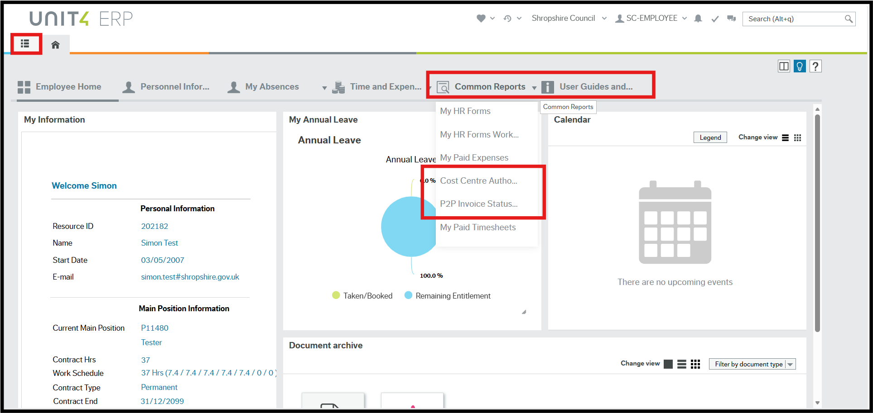

From here you can click on the following tabs for general purchasing reports and purchasing videos.

Common Reports – Access to the Cost Centre Authoriser Enquiry and P2P Invoice Status Enquiry.

Cost Centre Authoriser Enquiry – This report shows who the named approver is for all Shropshire Council cost centres at every level (£).

P2P Invoice Status Enquiry – This report allows you to search against a range of criteria including transaction, invoice and order numbers.

User Guides and Supporting Info Links - Access to useful intranet links, user guides and “How to” videos.

The Main menu can be found on the tab next to the home page.

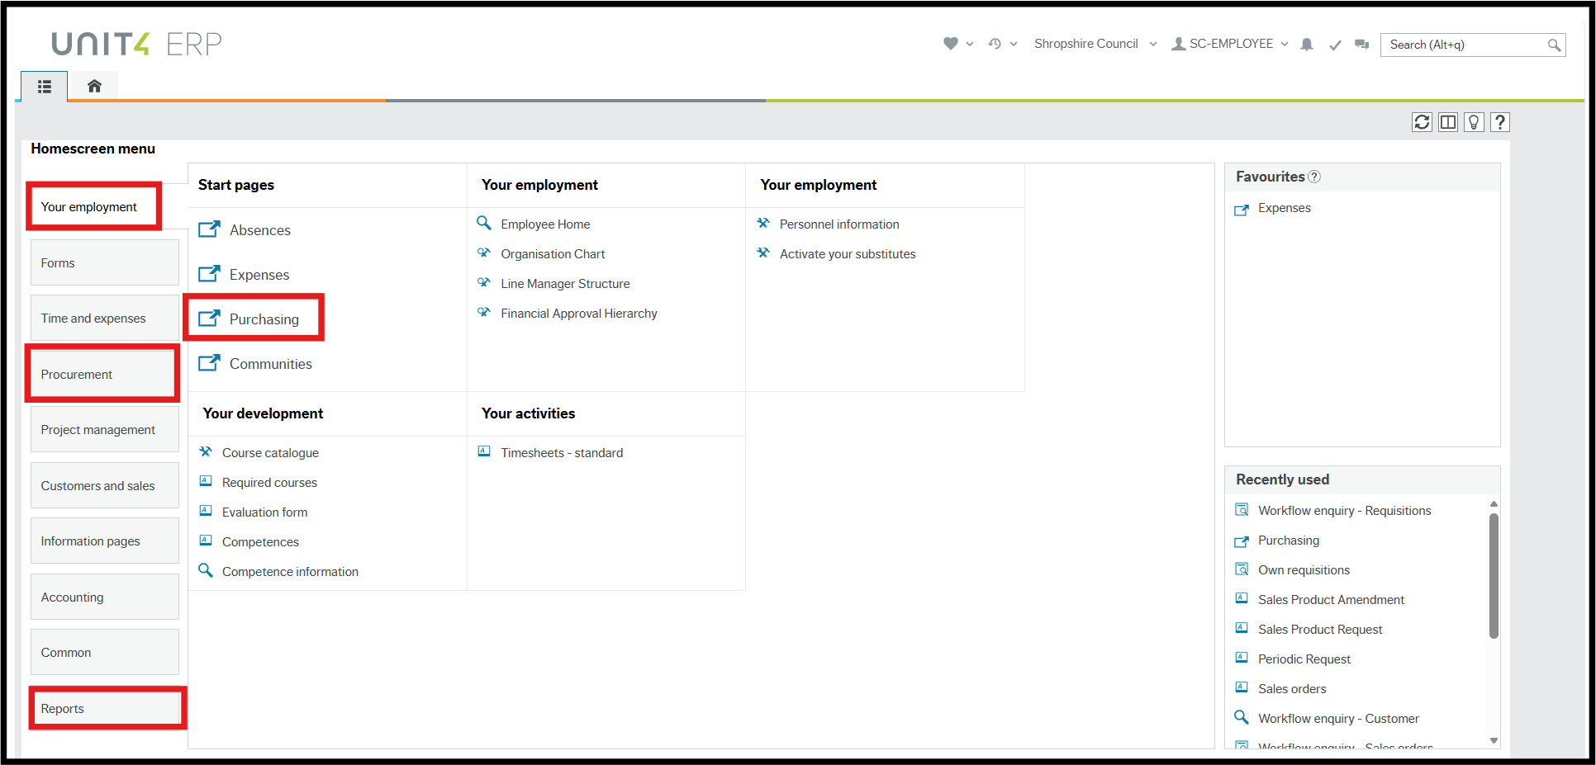

From the Main menu you can navigate to the Your Employment menu then go into Purchasing to raise a requisition.

After raising the requisition, you can then navigate to the Procurement menu where you will find a menu for Requisition information with a Workflow Enquiry and Purchase Order details including goods receipting.

There is a Reports menu where you’ll find your Requisitions, Orders and Goods Receipts reports under Global Reports > Finance and Procurement > Finance > Budget Monitoring and I&Es > Orders/Requisitions

Global Toolbar

The Global Toolbar is visible from every screen in the ERP.

Favourites - You can bookmark your most used functions (including forms and reports) by clicking the heart in the top right when in that screen and then accessing them by clicking on the heart on the Global Toolbar in the ERP or on the right-hand side in the Main Menu.
This can be useful for quickly navigating to frequently used pages or reports and can save time by reducing the need to search for these pages or reports each time you need them.

Recently Used - The ERP will save shortcuts to your 20 most recently opened and closed screens. They can then be accessed by clicking the clock icon on the Global Toolbar or on the right-hand side in the Main Menu. This can also help to quickly navigate to frequently used pages or reports and can save time.

Legal Entity - This displays the organisation you are logged in to i.e. Shropshire Council.

User - This displays your Username. In the dropdown you can Clear the Cache under About Unit4 ERP, change your password under Your Profile and Logout.

Alerts - If an action has taken place within the ERP that you need to be notified about, then you will receive an Alert which appears as a tick and/or a number on the Global Toolbar. Alerts provide information that may be useful to you but do not require any action.

Tasks - If an action or a request has taken place within the ERP that you need to authorise or respond to, then you will receive a Task which appear as a tick and/or a number on the Global Toolbar. Tasks are generated to notify a person or team of an action requirement that is specific to each type of transaction and approval level.

Collaboration - This is a messaging function for ERP users.

Search - The Search function is accessible on the Global Toolbar and can also be accessed by pressing (Alt+q). You can start typing which function or form you need to go into and then click into it from here.

Page Toolbar

The Page Toolbar icons will change to reflect the open screen.


Split View - This feature allows you to view and compare different sets of data in a single screen. This can be useful for analysing and comparing data from different perspectives, or for comparing data from different time periods.

Open Documents - Supporting documents can be added to records and forms as attachments. Attachments can be added and viewed by clicking on the paperclip in the top right corner.

Knowly – There are in-system guidance notes (Knowly or Knowlies) that can be followed whilst working in that screen. They can be found by clicking on the blue lightbulb in the top right.

Favourites - You can bookmark the screen you are in by clicking the heart in the top right when in that screen. They can then be accessed by clicking the heart at the top of every screen in the ERP or on the right-hand side in the Main Menu.

Help – Opens generic Unit4 guidance information.

Main Menu

Click on the Homescreen Menu button to bring up the Main Menu screen.
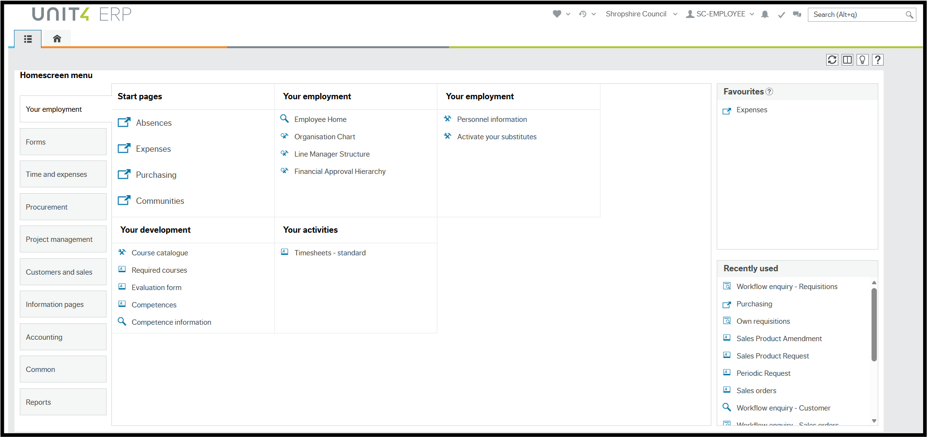

Main Menu – menu options available for your access.

Content Pane - is where the contents specific pages are opened and worked in.

Favourite Pane - contains shortcuts to any page you add to it.

Recently Used Pane - contains shortcuts to recently opened and closed pages.

3.4.1 Favourites

Favourites is a means of bookmarking your most used functions to quickly navigate to frequently used pages or reports. This can save time by reducing the need to search for these pages or reports each time you need them.

To add a page as a Favourite, click the heart in the top right when in that screen. The icon will become blue. Clicking it again will remove it from the Favourites list.

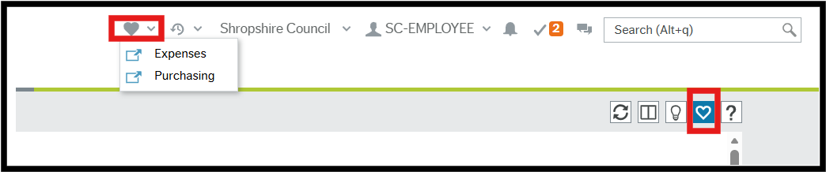

Favourites can be accessed in two places; the Favourites icon on the Global Toolbar or the Favourites pane in the Main Menu.

3.4.2 Recently Used

The Recently used pane is a list of shortcuts to the 20 most recently opened screens, whether or not they are in the Favourites pane. Each new screen that is opened is automatically added to the Recently used pane.

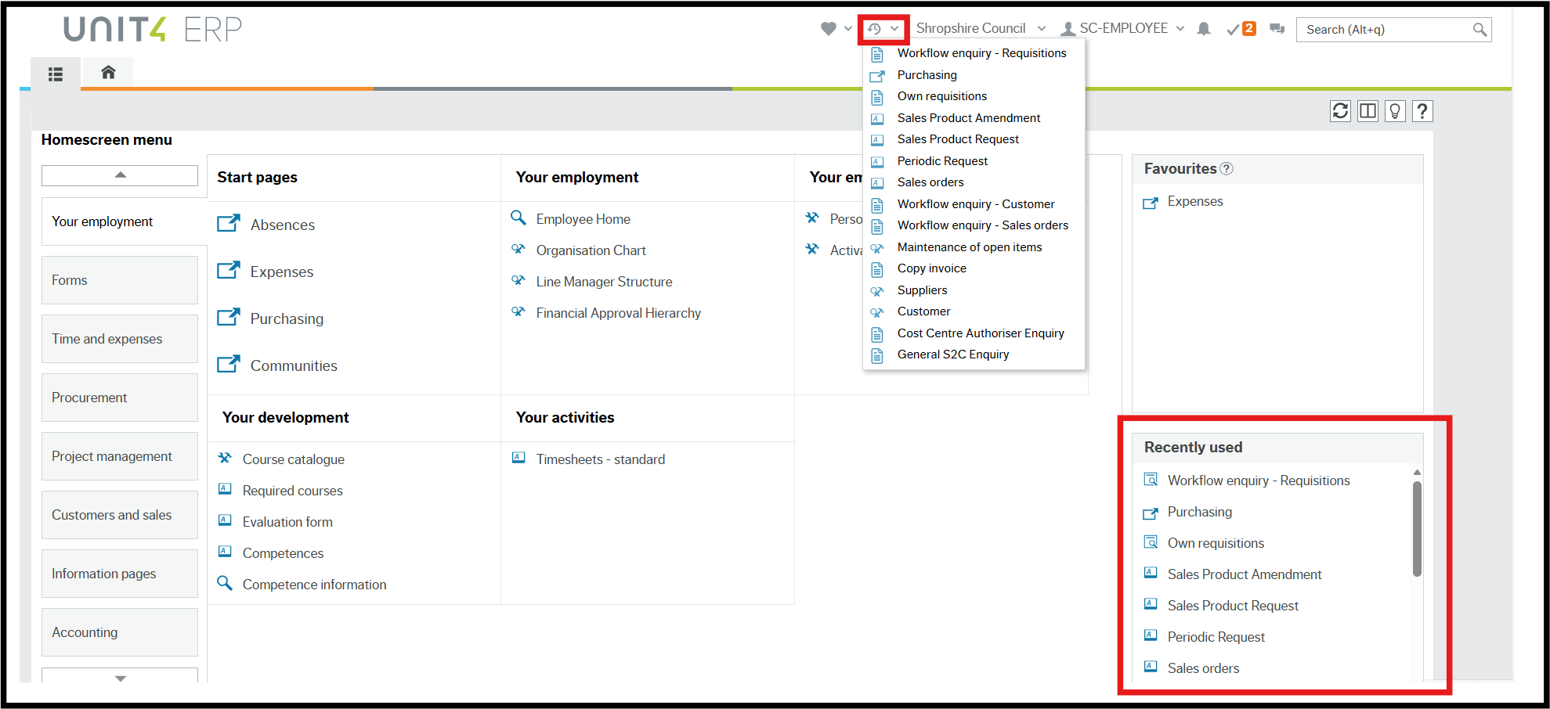

It can be accessed in two places; the Recently Used icon on the Global Toolbar or in the Recently Used pane in the Main Menu.

3.4.3 Split View

The Split View function allows you to have two screens open at the same time.

Open the first screen that you want, Purchasing in this example, and click Split view.

The Menu is now open to the right of the selected screen and the split view icon is blue. Select the next screen to be opened from the menu, Suppliers in this example.

Both the Purchasing and Suppliers screens are open at the same time.

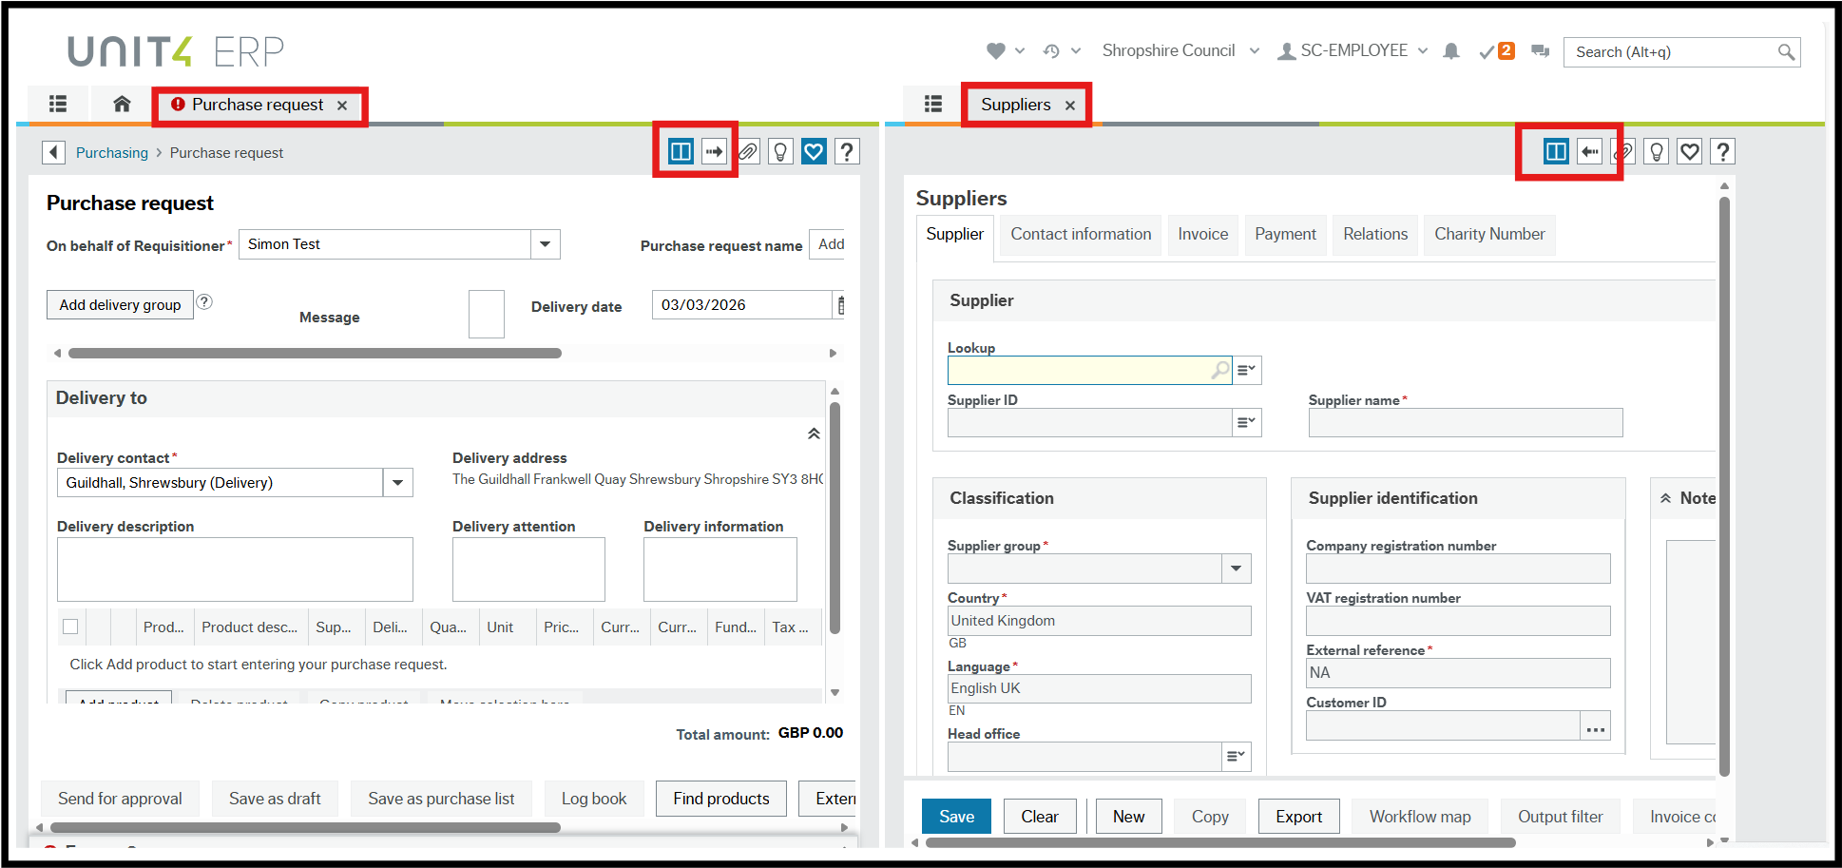

To return to a single screen, click Split view again and now a single screen is open but there are now two Screen tabs available.

3.5 Tasks

Workflow tasks are generated in the ERP according to a set of rules which are:

- Specific to each type of transaction

- Specific to approval levels

Workflow tasks ensure the following:

- The correct person or team is notified of an action requirement

- A link is provided to open the correct screen for actioning the task

- The relevant action options are available

Requisitioners could get the following tasks when using the ERP:

- Supplier required

- Price required

- Requisition rejected

- Close requisition

- Missing goods receipts

The ERP will notify you if you have been sent any workflow tasks for actioning. A number will show against the tick on the global toolbar:

If you do have any tasks, do not open them from the toolbar, go to Main menu > Common > Workflow > Task management or use the shortcut in the Global Toolbar and action from there.
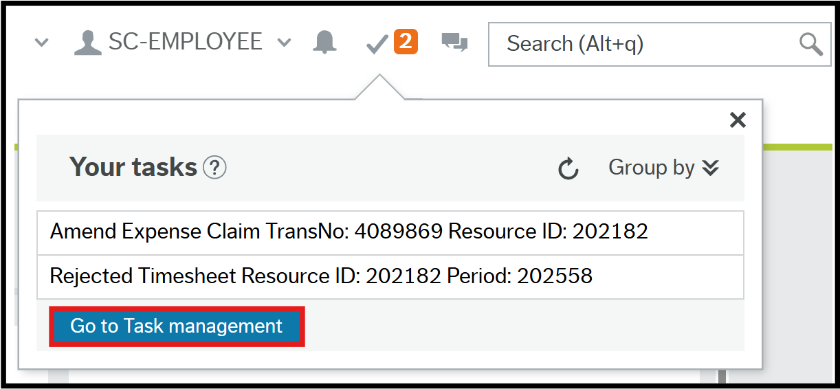

Task Management

To action any workflow tasks, go to Main menu > Common > Workflow > Task management.

Within Task management the tasks are listed and categorised for convenience. You can search by requisition number or invoice transaction number or you can choose to sort and group the tasks your own way.

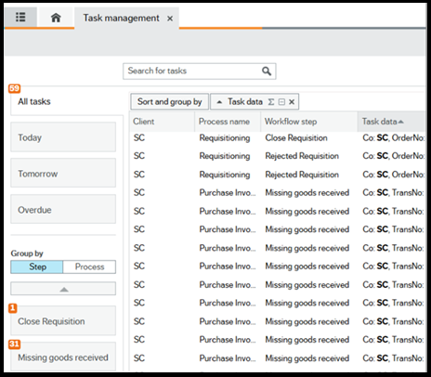

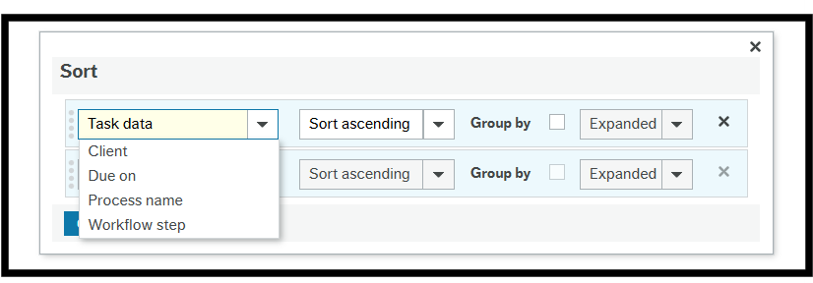

Click on the task you wish to action to view full details, once the task is complete, the next task will appear automatically but you don’t need to action that one. You can select whichever task you wish to action next.

Raising Requisitions

4.1 Non-Catalogue Requisitions

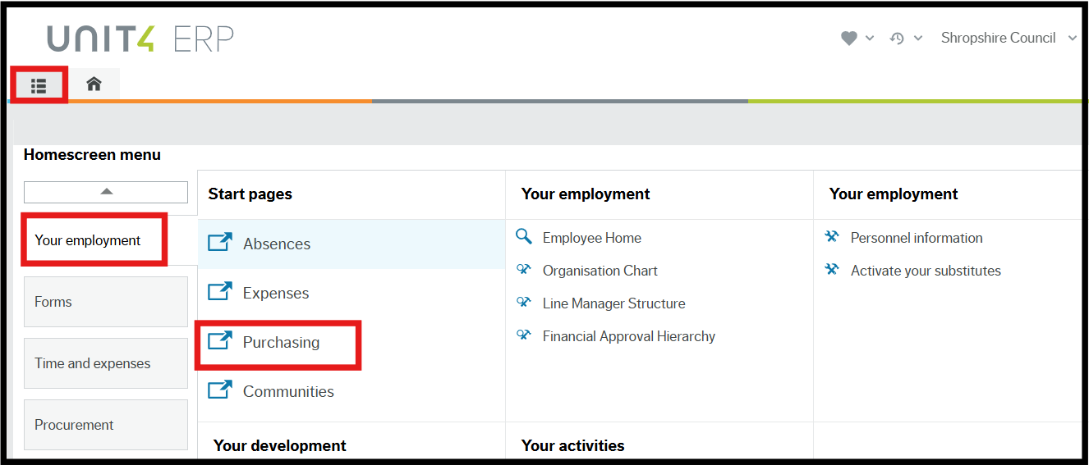

To raise a non-catalogue requisition, navigate to:

Main menu > Your employment > Purchasing

After you click on the Purchasing button, you can click on the Purchase Request button to begin the Requisitioning Process.

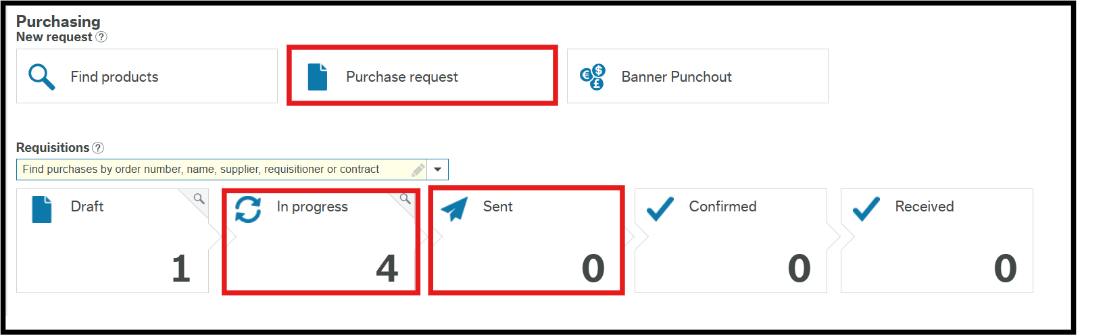

In progress – This will show any requisitions you have created that are awaiting approval by the authoriser.

Sent – This will show any requisitions of yours that have been generated into Purchase Orders.

4.1.1 Message Field

First, you need to complete the Message field. These answers will be visible to the spending control board but will not appear on the purchase order. The following questions must be answered within this field otherwise your requisition will be rejected:

Question 1 - If there is not a contract in place how did you secure value for money in line with the Council's procurement thresholds?
Question 2 - Is this part of a larger spend which has already been approved by this process?
Question 3 - Is there sufficient budget to meet this spend?
Question 4 - Is this expenditure funded from a grant?
Question 5 - What is the impact risk if the spend is not approved?

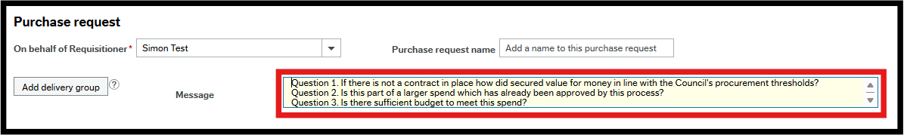

4.1.2 Header

Next, click on the Header button and the following options will appear:

Supplier – You can type in the Supplier ID you wish to use, start to type in the Supplier Name to select the right ID or use the lookup to search.
Period – leave as the default.

External reference – this is a free text field that can be used and appears on purchase orders.

Cost centre – Your Cost Centre will default in here but you can change this if required.

Purchase Order Delivery Type – You can press SPACEBAR and select SUPP if you want the order to be emailed to the Supplier once approved or USER if you want the order to be emailed to yourself once approved.

Is this a retrospective purchase order for goods or services already arranged? – Select Yes or No, this will not appear on the Purchase Order issued to the supplier. As per the Financial Rules, PO’s are required to be raised and approved at the point of order, so retrospective PO’s should not be used.

Contract Reference - Select the reference number for your contract. If you cannot find your contract in the list, you need to choose Register N/A where your contract is not yet on the contracts register or No Contract if there isn't a contract in place. If you don't have a contract and you choose no contract, you will need to have provided details regarding this in the Message field.

Price Suppressed on Req/PO – You can press SPACEBAR and select N if you don’t want the price to be hidden on the order that the supplier will receive or select Y if you would like the price to be hidden.
Close – You can click Close once you have completed the other fields in this section.

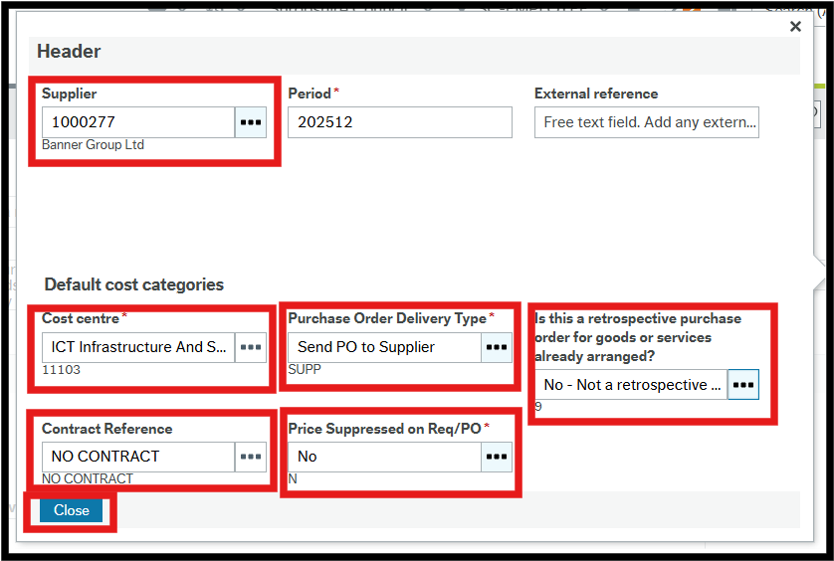

4.1.3 Delivery to
Delivery address defaults to Shropshire Council HQ. This can be changed using the drop-down list of delivery addresses or a requisitioner can email ERP@shropshire.gov.uk and request a default delivery address be added to your resource.
Delivery contact - This is the requisitioner default address but can be changed using the drop-down list.
Delivery address – This is the delivery address related to the Delivery contact field.
Delivery description – If the delivery address required isn't on the list, or if you need to give further instructions like a particular place on that site where they need to go or parking restrictions, additional information about delivery can be added here.
Delivery attention – Allows the name of a contact person or department to be added.
Delivery information – Allows such things as open times to be added.
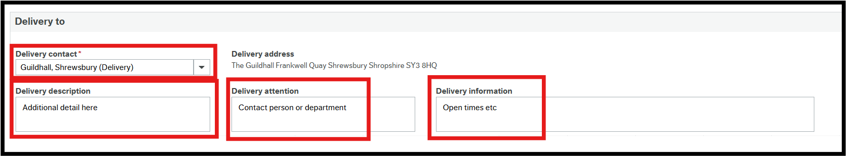

4.1.4 Product Lines
Your next step is to click on the Add Product button and begin to enter your product details.
Product – You can type in the product code you wish to use, start to type in the product name/group to select the right ID or use the lookup to search. If you are unsure of the product code you need to use, you can review the Product Masterfile list attached to your intranet guidance.
Please Note: The majority of products are generic and so the person who places the order will have to add the additional product detail in the Product text section when placing a requisition so that this appears on the order that the supplier receives.
Product description – The default product description is populated from the Product field.
Supplier – The supplier is populated from the Supplier field in the Header.
Delivery Date – The default date is today and can be changed using the calendar.
Quantity – This can be entered by typing or using the up and down arrows.
Unit – This will populate as EA (each) once the Product has been selected.
Price – Enter the price per item when ordering goods.
Currency – This field is read only and defaults to GBP.
Currency amount – This is calculated by the ERP as the Quantity x Price.
Funds check – This is where a warning appears if the order value exceeds 90% of the remaining budget for the Cost centre or Account code. Funds check warnings can be ignored by both the Requisitioner and the Approver as additional budget may be in the process of being added or may be added later.
Tax Code – Tax code is defaulted from the Product code but if you need to amend it, you can do this in Additional information (see below.)
If you wanted to add an additional product you would just click on the Add Product button again. If you wanted to order a product for a different delivery address you can click on the Add Delivery Group button and enter the product line under a new delivery address.
If different Suppliers are used on the same requisition, a PO will be produced for each supplier.
No PO will be produced until every line on the requisition has been approved.

4.1.5 Additional information
After entering these details you can then click on the magnifying glass icon to add any additional product detail and check that the correct Cost centre, Account code and Tax code have been used and amend if required.
The Cost categories tab contains the GL Analysis for the selected product line.
Account – This is the product Account code. The product name/group is displayed in the field and the Account code is displayed below it.
Cost Centre – The Cost Centre will default here but you can change this if required.
Project code and Sub Project codes – These fields are only visible for Capital Account codes or Cost centres and are mandatory to facilitate project-based reporting and controls. This removes the need to set up new cost centres for capital schemes, as this can be managed at project/sub-project level. The account rule on capital Account codes is configured, so the user just needs to input the Sub Project code and code completion is used to automatically populate the Project code and Cost centre. Press SPACEBAR in the Sub Project field to bring up all the options available, press tab and the Cost centre will change to the correct one for that sub project.
Analysis – Only visible for construction and maintenance requisitions (see section 4.4), press SPACEBAR to select the type of work to be carried out.
Labour or Materials Element - Only visible for construction and maintenance requisitions (see section 4.4), select either Labour or Materials.
Legal entity – This is read only.
Tax Code – Tax code is defaulted from the Product code but if you need to amend it, press SPACEBAR to bring up a list of all the codes and select the correct one.
Percentage – This displays the percentage of the payment relating to the selected Cost centre.
Amount – This reflects the percentage of the requisition total cost to be attributed to the Cost centre selected.
Funds check – This is where a warning appears if the order value exceeds 90% of the remaining budget for the Cost centre or Account code. Funds check warnings can be ignored by both the Requisitioner and the Approver as additional budget may be in the process of being added or may be added later.
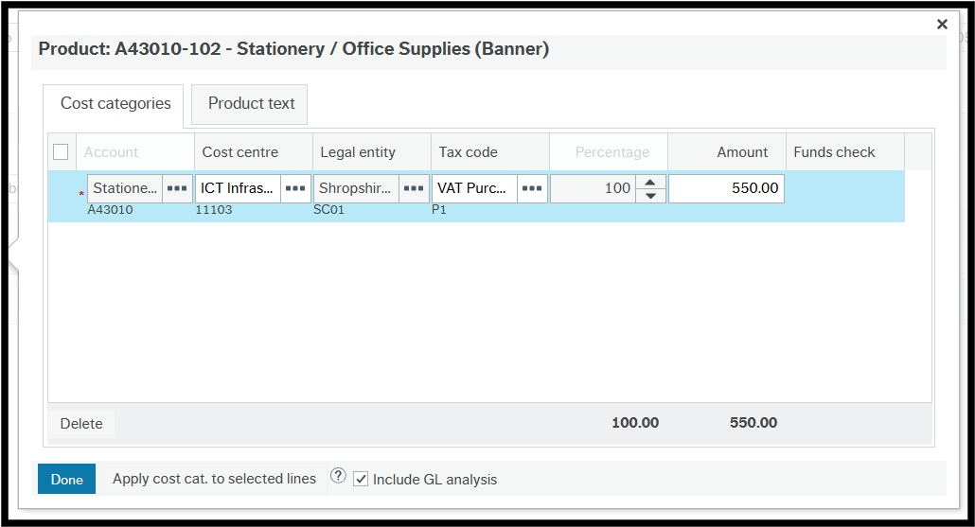
If you are happy with these, you can click on the Product text box to add your additional product detail requirement.
Product text – This is an area where additional information about the product being ordered can be added as clarification such as size or colour.
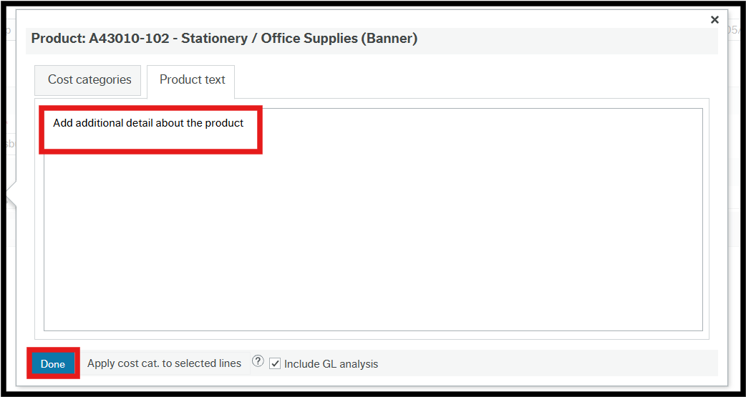
After you have entered your additional product details you can then click on the Done button.

4.1.6 Complete the Requisition
At this point, the requisition can either be saved as a draft for future editing or can be sent for approval. To save what has been done so far, click Save as draft. Further editing can be carried out at a later date.
To open your saved draft go to your Purchasing New request home page and click on Draft. Any draft requisitions will be listed for you to select from.
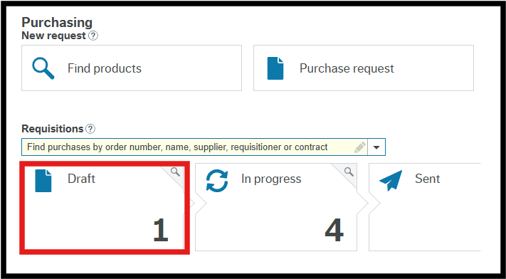
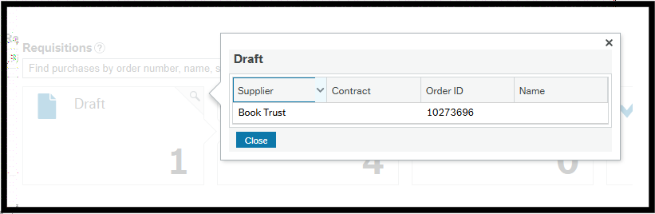
Alternatively, you can use your “Own Requisition” enquiry to open the draft requisition. The workflow status will show as No workflow until you send for approval. Once approved, a purchase order number will appear on this report against the draft requisition.
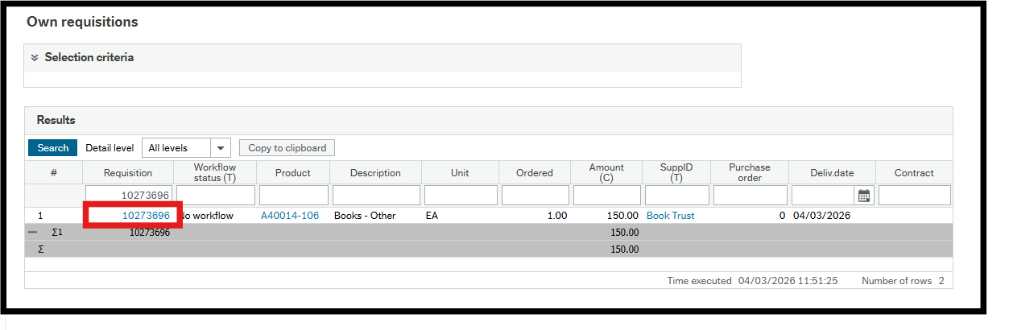
The final step is to click on the Send For Approval button if you are happy with your requisition.
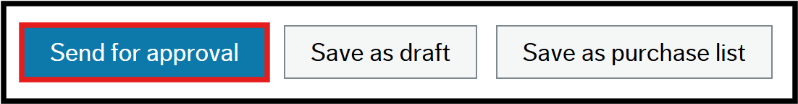
After you have clicked on the Send For Approval button, a notification will appear stating that that your requisition has been created.
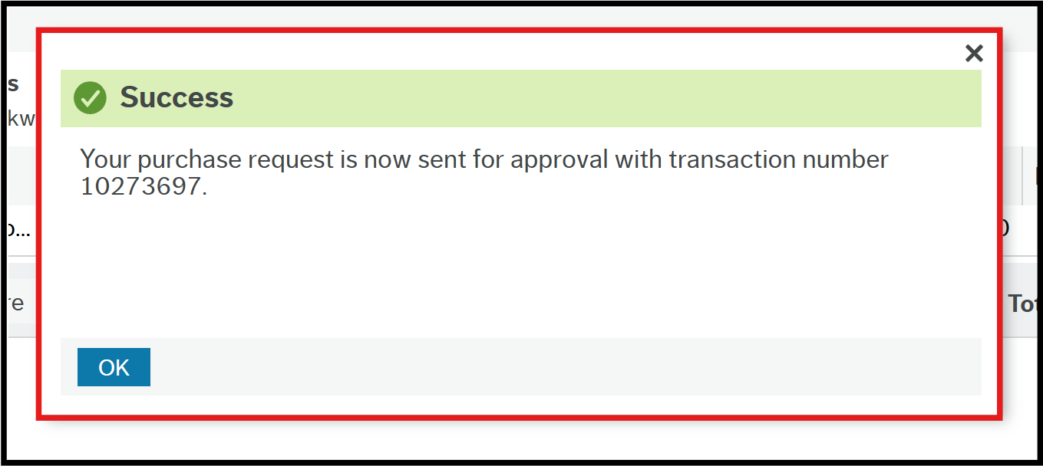
Once a requisition has been sent for approval it will enter workflow. All workflow steps must be completed before a Purchase Order is generated. Only then will the order be sent to the supplier or requisitioner. Workflow steps vary depending on the data used on the requisition however you can check the workflow status of your requisition on the Workflow Enquiry – Requisitions report. This can be found in the Procurement menu > Requisitions > Enquiries.

4.1.7 Funds Check Warning
If the order is likely to exceed 90% of the available budget for the Cost Centre/Account Code, the following warning will appear.
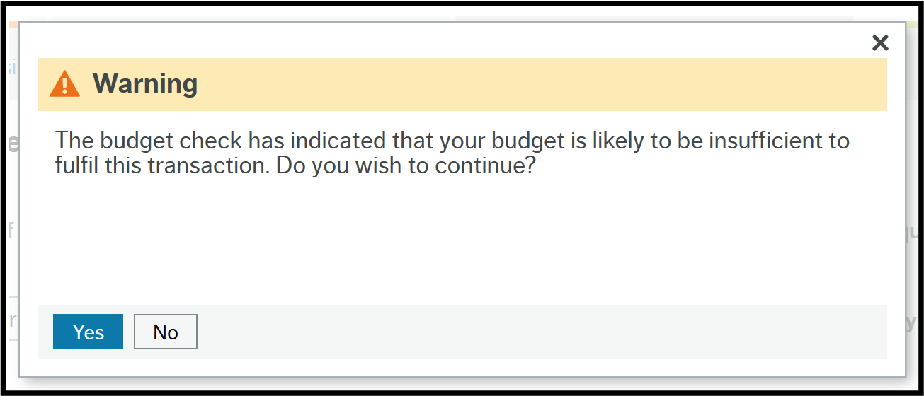
Click Yes to ignore the warning, which closes the popup and sends the requisition into workflow.
Click OK in the Success window to close it.

4.2 New Request via Find Products
- Navigate to Main Menu > Your Employment > Purchasing
- Click on Find products.
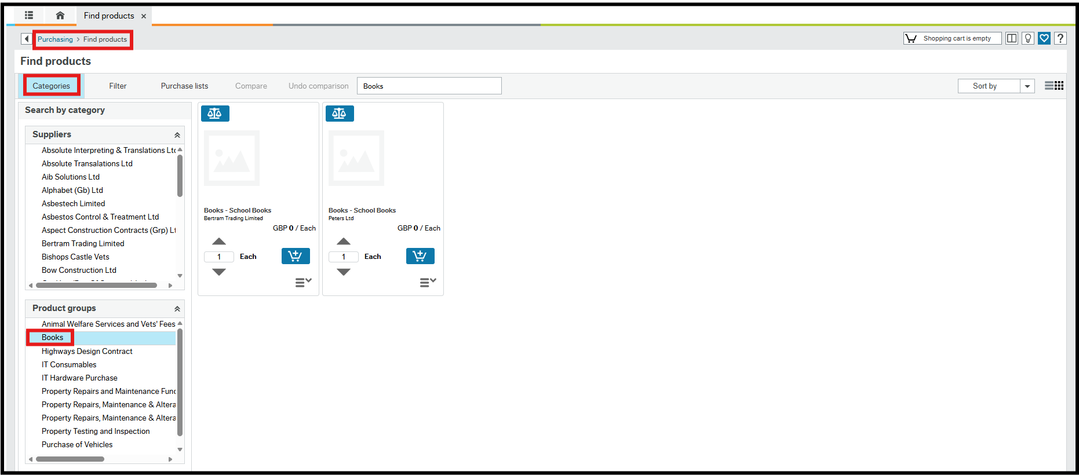
Categories – This is selected by default, allowing products to be searched for by Supplier or Product group. You can also type the search parameter into the search field.
Filter – This becomes the active tab and the content pane is populated with the results when the search parameter has been determined.
Purchase lists – This displays those products that you have added to your Purchase lists from a requisition. You can select the product line in the content area, enter the quantity and click Add to Basket in exactly the same way as the example below.
In the example above the Product group Books has been selected which is then automatically populated in the search field. At the same time, the related results are populated in the Content Area.
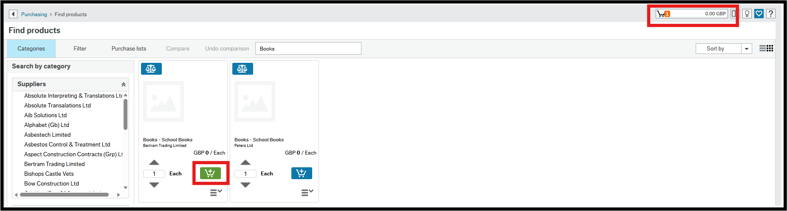
3. Scroll to find the required product.
4. Enter the quantity or use the arrows to select the select the quantity.
5. Click the Add to Basket icon.
6. Repeat steps 1-3 until all products have been added.
7. Click in the Cart field to open the popup.

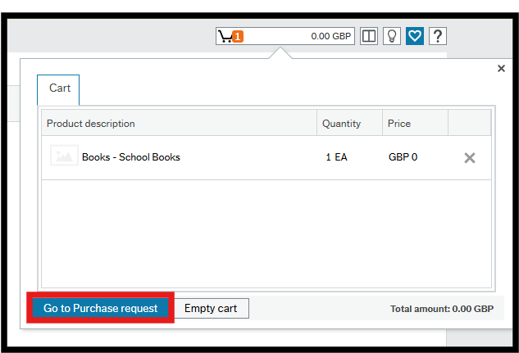
The shopping cart can be edited at this stage.
8. Click Go to Purchase request.
The Purchase request screen is opened with the Product line(s) populated from the shopping cart.
Then complete the purchase request as shown previously.

4.2.1 Save to Purchase List
It is possible to add any of the products in the requisition to your Purchase Lists, which is the third tab on the Find Products start page, making it quicker and easier to find regularly ordered, or difficult to find products.
- Select the product line to be added.
- Click Save as purchase list.
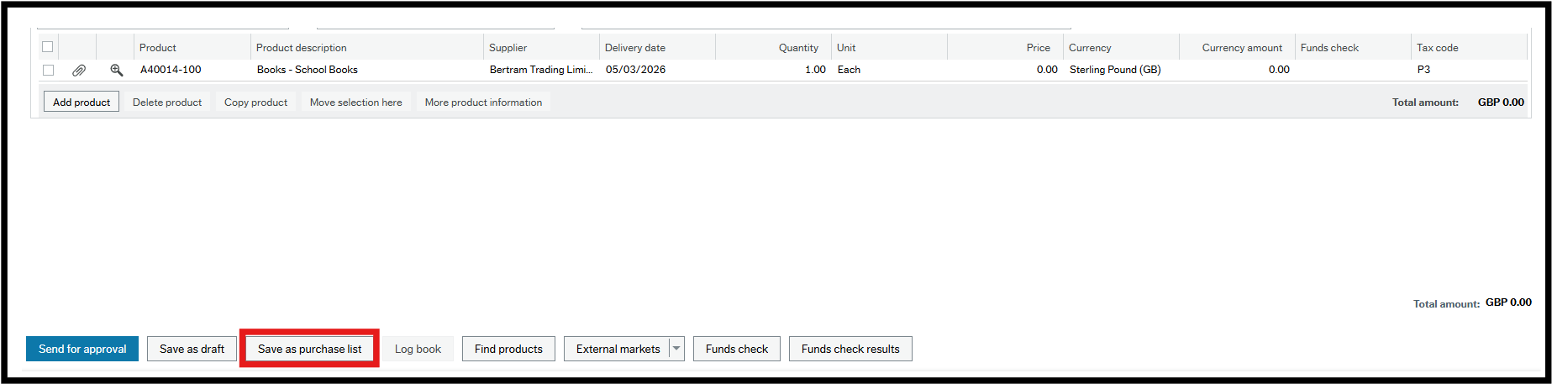

Name – Enter a name for the product.
Description – Enter a description for the product.
Save without quantity – This is the default setting.
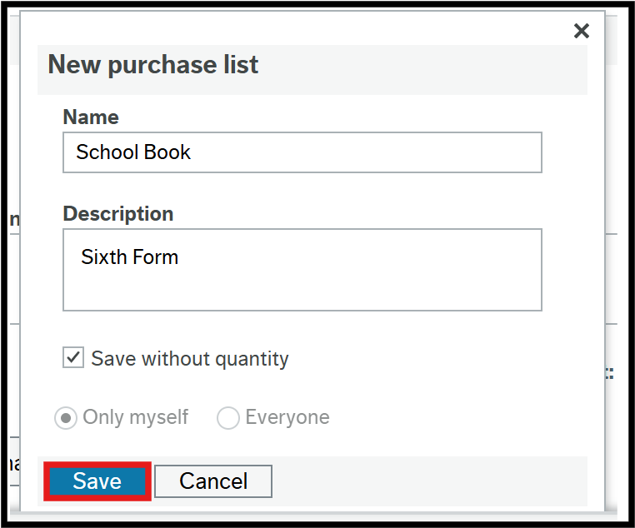
- Click Save.
A confirmation popup will open and then close after a few seconds.

4.3 Call-Off Orders

If you receive regular invoices from a supplier but the amount and frequency of these invoices differ, it may be suitable to create a call-off order. Call-off orders are where you are ordering a value rather than a quantity. Examples are: maintenance of office equipment, consultancy and contract building work where invoicing may be periodic, on a call out basis or by milestones in a project.

With a Call off order you are giving the supplier a ‘permanent order number’ (usually for the financial year) and asking them to quote this on each invoice they send in to you.

When placing a requisition you can select a specially set up Product Code that will have ‘(Call Off Order)’ in the description.

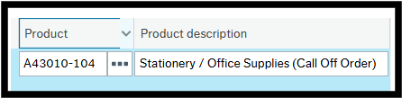

The quantity will default to 1 and cannot be edited and in the Price field you can enter the amount you are expecting to spend with the supplier.

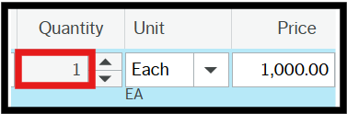

When you goods receipt your call-off order, you need to goods receipt the unit price, and not the quantity, to the value of goods received. This allows partial (periodic) receipting to take place. In turn this allows 3-way matching and payment to take place for partial invoicing.

4.4 Requisitions for Construction and Maintenance
HMRC tax rules for suppliers who are part of the Construction Industry Scheme (CIS) mean that sometimes suppliers will get paid with tax already deducted. This is set up in the Supplier Master File and actioned automatically against payments. To allow this to happen, a requisition for both labour and materials must be shown clearly on 2 separate lines, one for labour and one for materials. Both lines will have the same product code and description. The value on each line will be part of the quote from the supplier.
Requisitions raised for the Labour element only, will only have one line.
CIS orders go through the workflow for checking by the Accounts Payable Team. If they think you have not got it right, such as the tax code selected, they will reject it back to you with instructions on what changes to make.

4.5 New Requisition via Punchout

Punchout is how you gain access to a supplier’s catalogue to add products directly from their catalogue to a requisition.

- Navigate to Main Menu > Your Employment > Purchasing > Banner Punchout

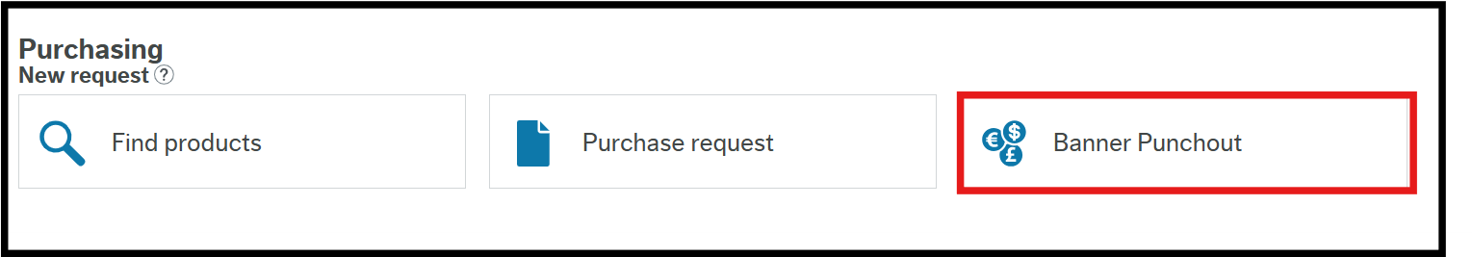

The Banner Catalogue opens in a new browser tab.

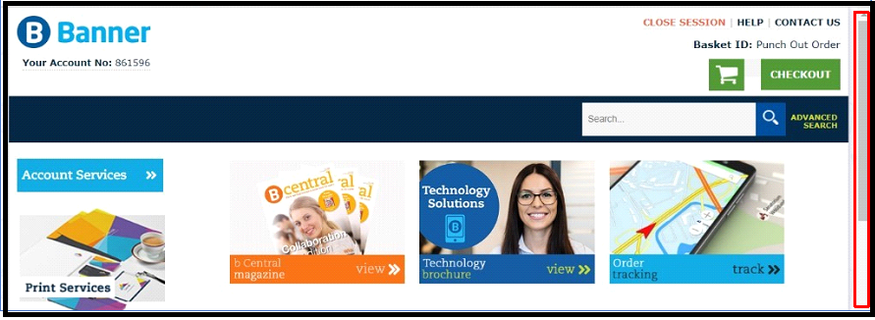

- Scroll down the page to see the product filters.

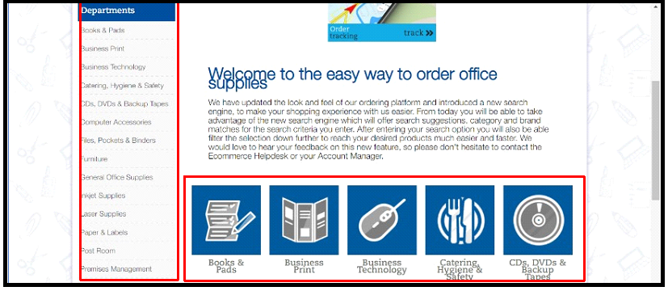

Products can be filtered by department from the left hand menu or the centre grid or the search bar can be used.

- Navigate to the required department product list.

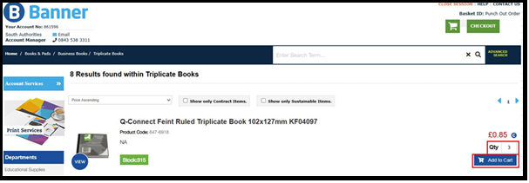

4. Enter the Qty.
5. Click Add to Cart.

A popup will tell you the cart has been updated. You can then click Checkout if you have finished shopping.

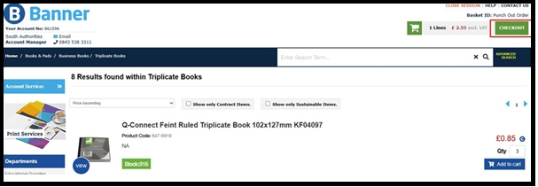

The basket will be displayed with options to:

Del – Delete product lines.
Qty – Change the quantity to be ordered.
Update Basket – update the basket to reflect deletions and changes of quantity.
Continue Shopping – returns you to the catalogue.

Useful tip: If the Website Optimises your product and you don’t want the optimised product, you can remove this optimisation by clicking on the Green Tick.

- Once happy, you can then click Continue or Proceed to checkout.

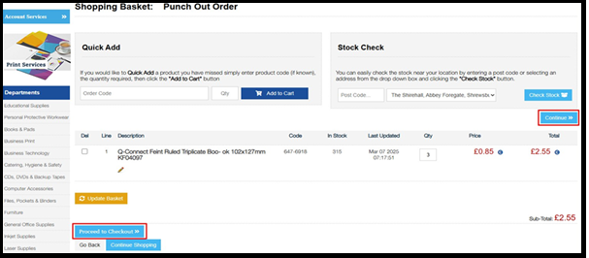

The Banner catalogue closes and returns you to the normal Purchase Request screen and the product lines will have been added to your requisition.

You can now just follow the normal requisition process by clicking on the Header field and populating any mandatory fields as shown previously.

4.6 Guidance for Key Product Types

The table below gives further guidance for specific product types.

Type of Good / Service | Required Action
Stationery | Banner is the contracted supplier for stationery orders, and you must place your requisitions through Punchout in the ERP to create a purchase order.
IT Equipment | There are a selection of laptops, tablets, monitors and other IT consumables that will be included as products in the ERP, and a purchase order should be created in the ERP for these. These are:  A45000-100 Lenovo E590 Laptop / Tablet - 20KTS08Y00  A45000-101 Lenovo Yoga X380 Laptop / Tablet - 20LH000NUK  A45000-102 Lenovo Miix 520 Laptop / Tablet - 20M30008UK  A45000-103 MS Surface Pro Laptop / Tablet - LPZ-00002  A45000-104 Surface Pro Docking Station  A45000-105 21.5" Fixed Height Monitor - E2275SWJ  A45000-106 21.5" Height Adjust Monitor - E2282HS-B1  A45000-107 23.6" Fixed Height Monitor - E2475SWJ  A45000-108 23.6" Height Adjust Monitor - E2475PWJ  A45000-109 27" Height Adjust Monitor - XUB2790HS-B1  A45030-100 Surface Pro Type Cover - FMN-00003  A45030-101 Wacom Bamboo Ink Surface Pen - CS-321  A45030-102 MS Arc Bluetooth Mouse - ELG-00002  A45030-103 Techair 15" Laptop Bag - TANZ0140  A45030-104 Kensington Easy Riser Laptop Stand - 60112  A45030-105 8gb Memory Stick  A45030-106 16gb Memory Stick  A45030-107 32gb Memory Stick  A45030-108 64gb Memory Stick
Furniture | Before attempting to order any furniture in the ERP, the requisitioner must register on Warp-It to see if their item is available there. Warp-It will show any available furniture present in the council that can be provided free of charge. If the item required isn't on Warp-It and the user places a requisition for furniture in the ERP, this request will be directed to Simon Maceachen (accommodation logistics officer) who will be able to approve/reject the requisition before it gets sent to the budget manager, and he will enquire whether the requisitioner has registered with Warp-It.
Agency Staff | All agency staff requests are currently done via the Opus portal.
Internal Services | Orders for internal council services such as room hire or printing services for the time being will be placed in the same way that they currently are, but internal products will be added to the ERP in the near future, which will mean the order is placed with the council service through the system, and then once the good/service is provided the user will be able to goods receipt this, which will create the journal entry.
Utilities | ‘No PO no pay’ won’t apply to invoices for utilities. Instead you can process these as supplier invoices.
Mobile Phones | These will need to be ordered through IT, as they currently are.

5. Attachments

5.1 How to add attachments to purchase request header

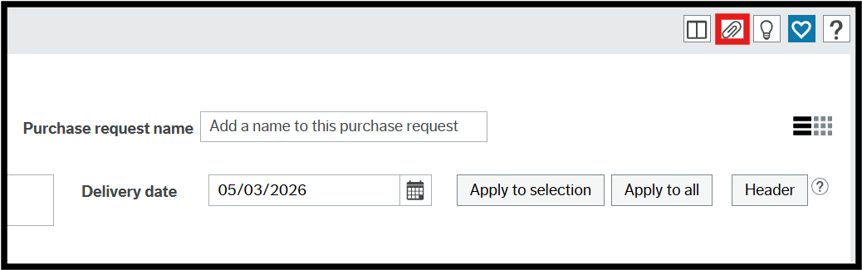

- Click Open documents – the paperclip icon at the top of the page.

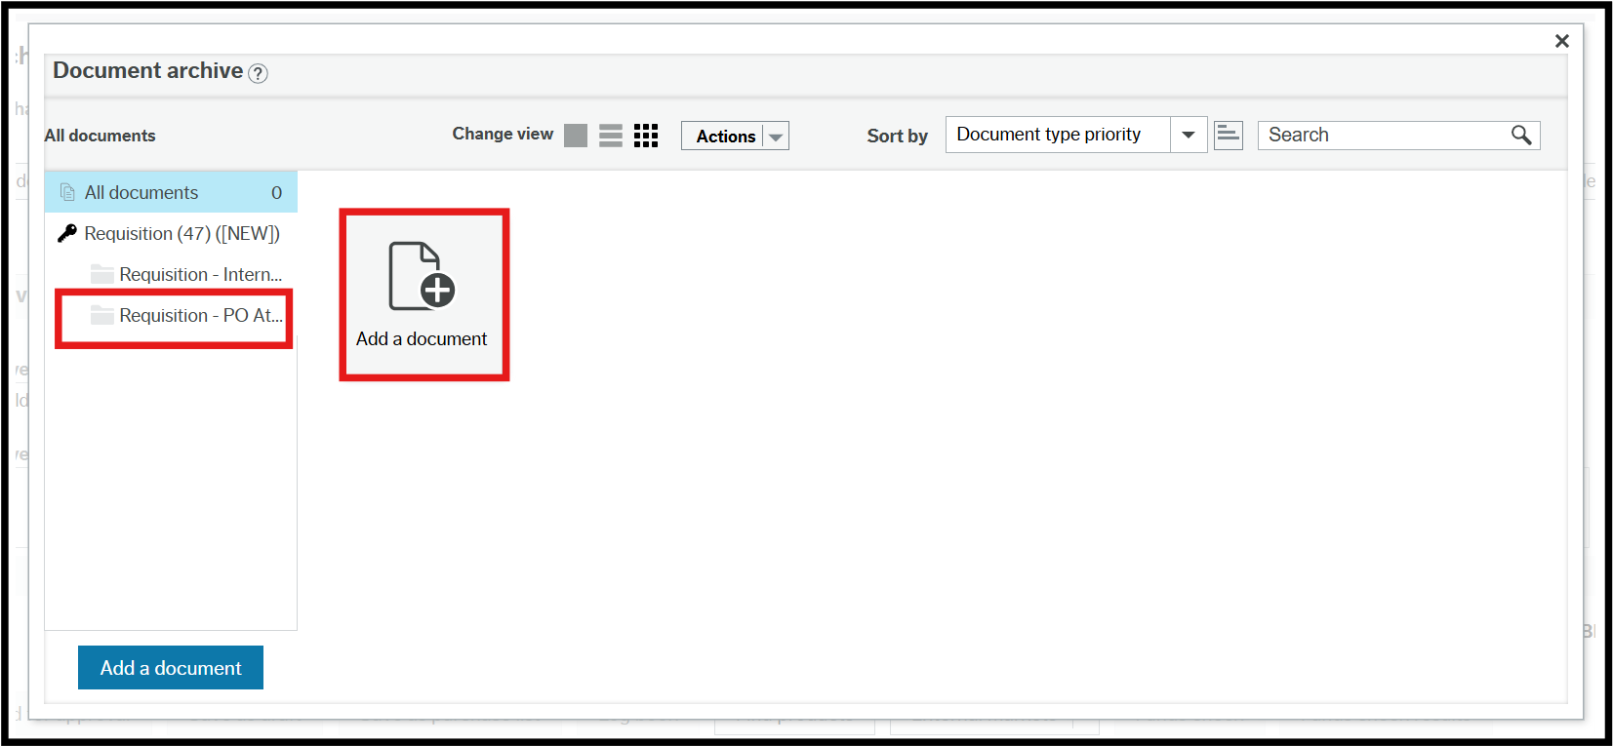

- Select the required document option for internal or external document.

- Click Attach a document.

The Add a document popup will open.

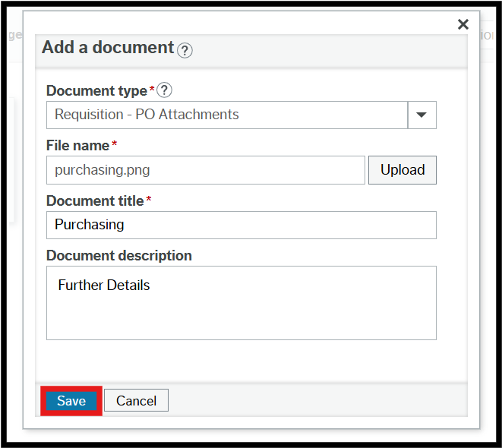

Document type – is the selection made in the menu on the left, but it can be changed using the drop-down.

File name – click Upload and navigate to the document to be added.

Document title – populates from the document properties.

Document description – can be added to give further details about the document contents.

- Click Save.

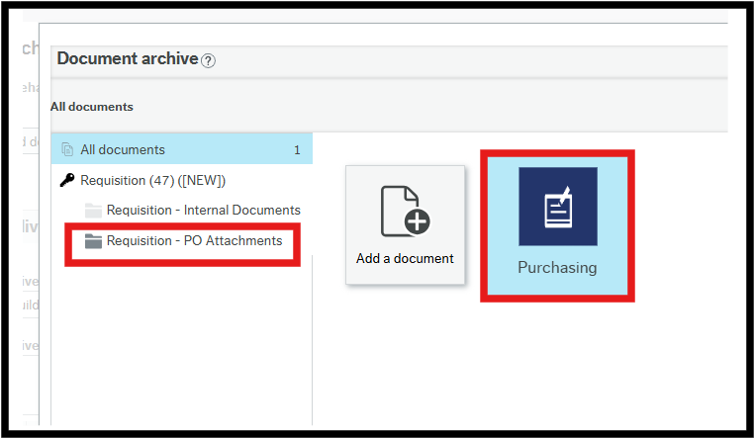
The attached document(s) can be seen in the Open documents popup for the type selected.

- Select All documents in the menu to see the attached documents of all types.

5.2 How to add attachments to the product line in a purchase request

All documents added to a specific product line will be sent to the supplier with the PO.

- Click Open documents – the paperclip icon on the requisition line.

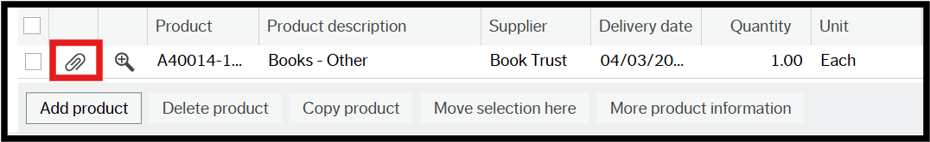

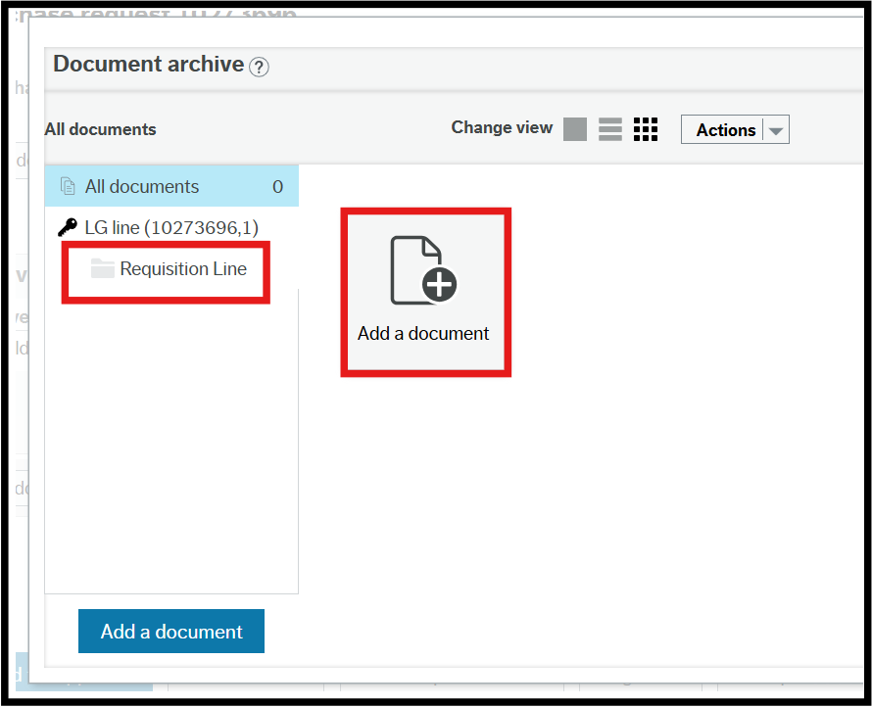

- Select Requisition Line.
- Click Attach a document.

The Add a document popup will open.

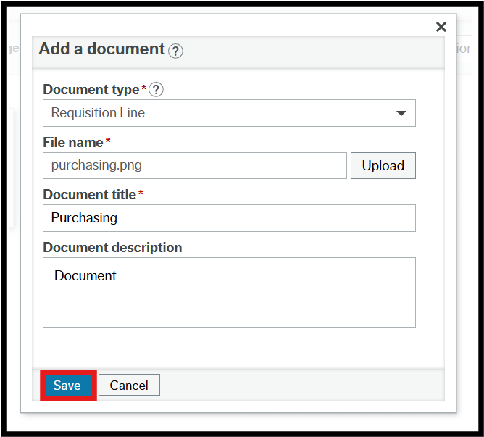

Document type – this cannot be changed as it is the only option.

File name – click Upload and navigate to the document to be added.

Document title – populates from the document properties.

Document description – can be added to give further details about the document contents.

- Click Save.

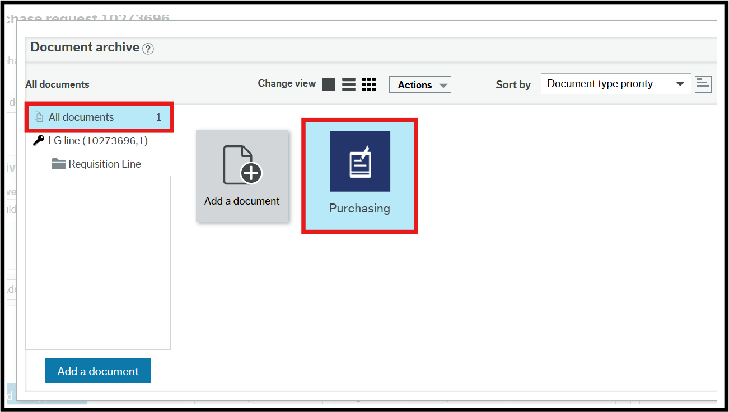

The attached document(s) can be seen in the Open documents popup for the type selected.

The requisition needs to be saved if you want to see the attachments at line level as it’s held against line number which doesn’t exist until the requisition is saved, as draft or after it has been submitted form.

Workflow Enquiry

Workflow enquiries allow users to see where their requisitions are in the process, what actions have been taken and who took them. They also show the expected workflow for actions yet to be taken.

- Navigate to Procurement > Requisitions > Workflow enquiry – requisitions

Selection criteria are entered at the top of the screen.

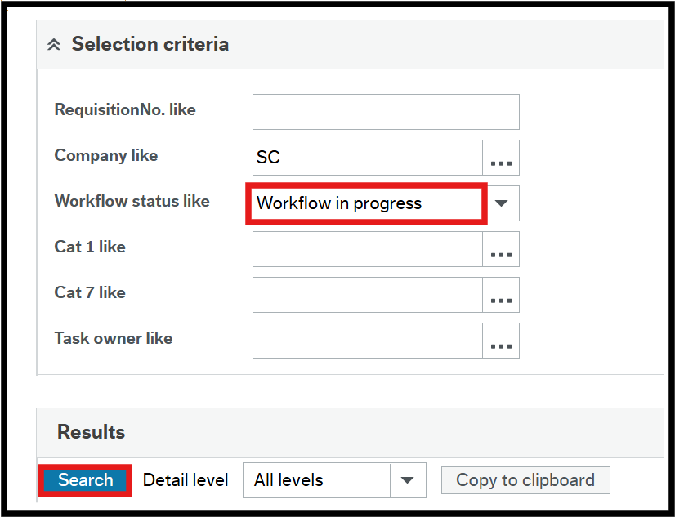

- Enter your criteria

RequisitionNo. Like - if you want to see a specific requisition, type the ID in here.

Company like – this defaults to your legal entity and cannot be changed.

Workflow status like – select the status you want to see, this will usually be Workflow in progress.

Cat 1 like - if you want to see a specific cost centre (Cat 1), type the ID in here or select from the lookup table.

Cat 7 like – if you want to search by different attributes (such as Legal Entity), you can use the lookup table to define.

Task owner like – if you want to see requisitions awaiting action by someone specific, select their name from the lookup table.

- Click on Search.

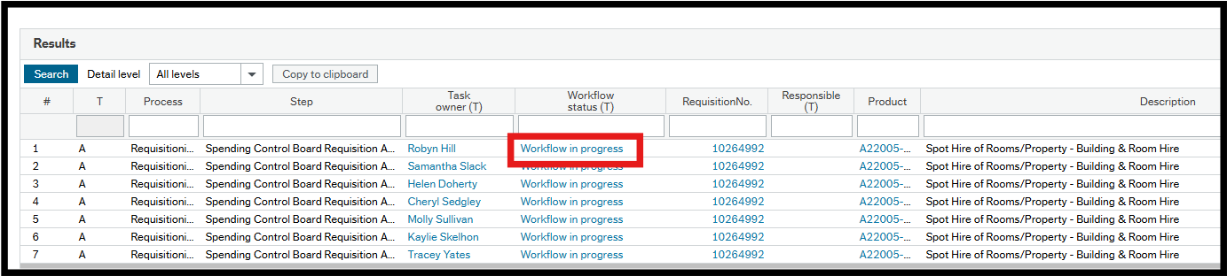

- Click on Workflow in progress for the required requisition.

The Workflow Map opens.

6.1 Workflow Map

The workflow map will show the path the requisition is expected to take, depending on the type of product and the value.

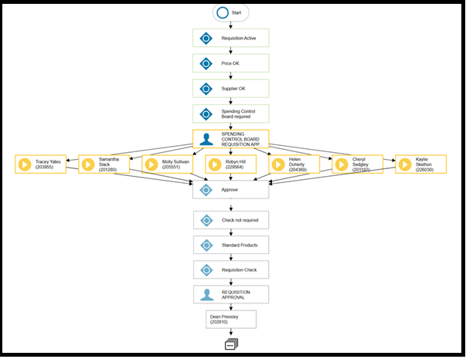

The system carries out checks to determine the route such as the following:

Price OK – Does each line have a price?
If Yes, go to the next step
If No, send Price required task to requisitioner

Supplier OK – If the product has a preferred supplier was it selected?
If Yes, go to the next step
If No, send to Procurement for approval
(No) Procurement Check Required – some products require Procurement approval.
If Yes, go to procurement team for Procurement Check
If No, go to the next step

Standard Products – Is it for standard products?
If Yes, go to the next step
If No, send for Technical Approval, this applies to IT and Furniture products

Requisition Approval – If the requisition requires either Procurement or Technical approval, this step would say Technical Approval, which always comes before financial approval.

Dean Pressley (for example) – This is the name of the person the requisition has been sent to for approval. This may be a row of names in individual boxes where anybody in a team can respond.

The last icon indicates there will be more to follow depending on the approval decision All steps are colour coded:

- Grey – step not reached
- Green – step completed as positive - Approved
- Red – step completed as negative – Rejected
- Yellow – solid means it is available for action. This may change to dotted when it is no longer available because one person in the team has actioned it already.

If a requisition approval task has not been actioned after 5 working days, the system will escalate to the next level (£) approver shown on the Cost Centre Authoriser Enquiry.

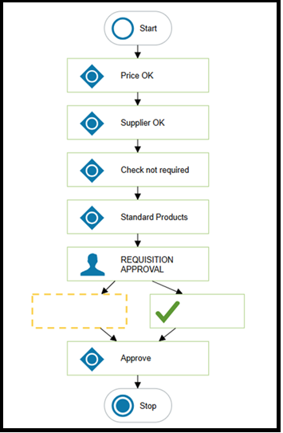

Tasks

7.1. Price Required Task

If a requisition enters workflow without a price the requisitioner will receive a Price required task.

- Click Tasks to open workflow tasks list.

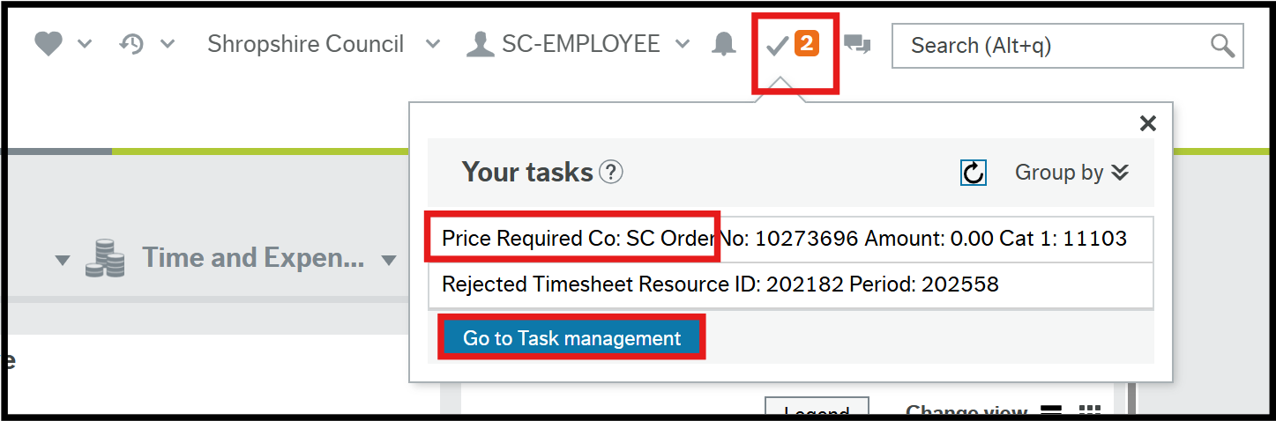

- Click Task Management to view and action any tasks.
Alternatively, you can go to the Main menu > Common > Workflow > Task Management if you see you have tasks for actioning. Never click on a task and try to action it directly from in the Task list, always view and action tasks from within Task Management.
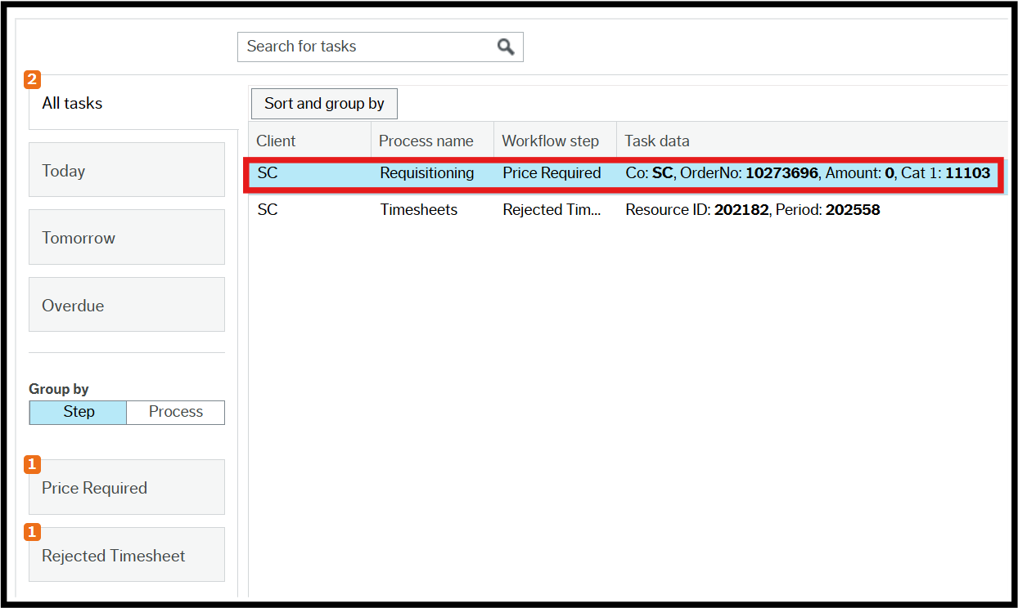

- Enter the Price
- Press Tab on the keyboard
- Click Resubmit

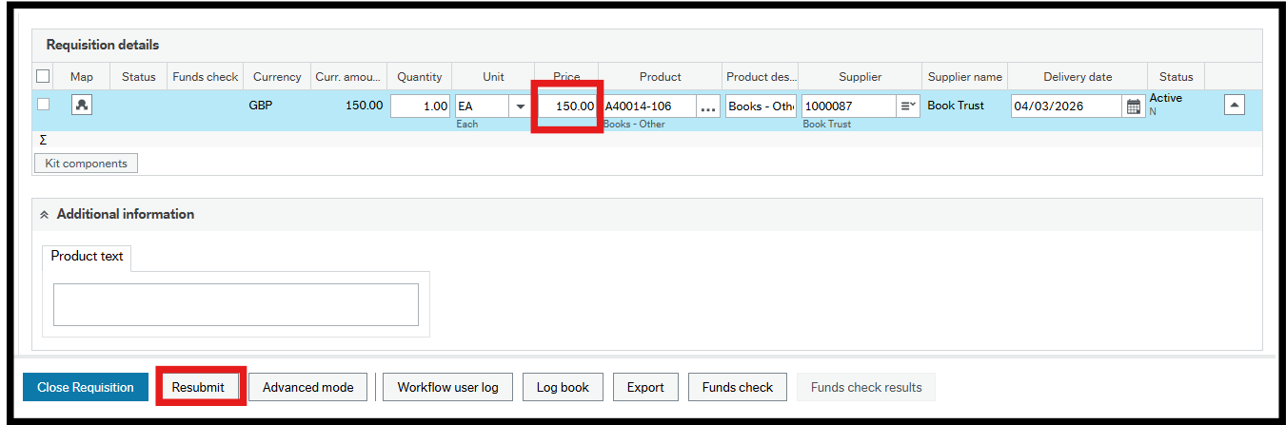

The Success popup will open.

- Click OK.

The number of outstanding Tasks is reduced.

7.2 Missing Goods Received Task

If an invoice is registered before the goods receipt, the requisitioner receives a Missing goods received task.

- Click Tasks to open workflow tasks list.

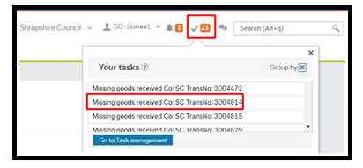

- Click Task Management to view and action any tasks.

Alternatively, you can go to the Main menu > Common > Workflow > Task Management if you see you have tasks for actioning. Never click on a task and try to action it directly from in the Task list, always view and action tasks from within Task Management.

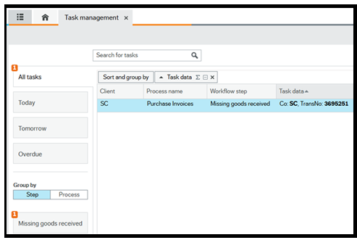

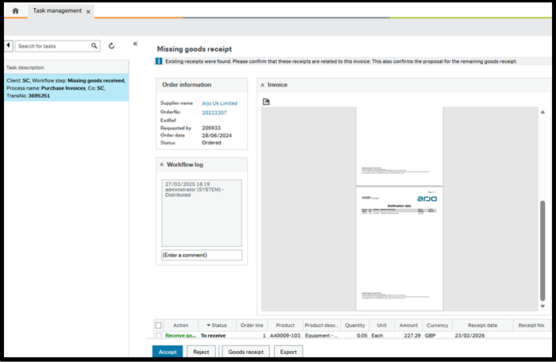

The Missing goods receipt screen opens. This displays an image of the registered invoice which can be compared to the PO product line(s.)

- Click Accept to fully receipt the selected lines and the screen becomes blank or
- Click Goods receipt to open the Goods Receipt screen and manually receipt amount and Save. It is very important that you receipt the Qty or the Price, depending on the type of order raised. If you leave these as 0.00 then you will receipt 0.00 and no goods receipt will be registered for the invoice.

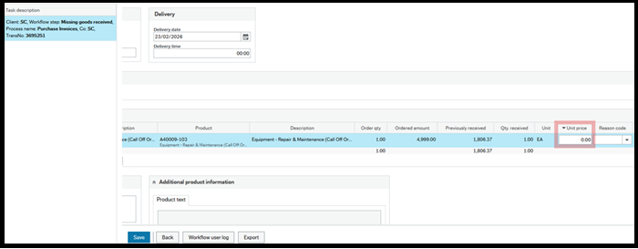

The number of outstanding Tasks is reduced.

7.3 Rejected Requisition Task

A requisition might get rejected and there are many reasons for this. Rejected doesn’t necessarily mean “no” but that a change is required or further action is necessary.
Only the person who raised the requisition (Originator) can action a Rejected requisition task and close the requisition.

- Click Tasks to open workflow tasks list.
- Click Task Management to view and action any tasks.

Alternatively, you can go to Main menu > Common > Workflow > Task Management if you see you have tasks for actioning. Never click on a task and try to action it directly from in the Task list, always view and action tasks from within Task Management.

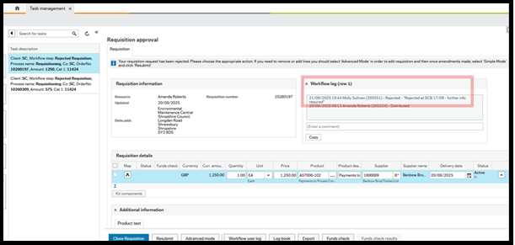

- Read the Workflow Log. Rejected requisitions must always have a reason entered:
- Click Close Requisition if the requisition is no longer required or
- Enter the changes and click Resubmit

The Success popup will open.

- Click OK

The number of outstanding Tasks is reduced.

7.4 Approval Tasks

A requisition will normally be sent to the named approver on the Cost Centre Authoriser Enquiry dependant on cost centre and value used. There are some exceptions to this, where transport account codes are used for example, there is a separate Authorisation Structure which the system uses to determine the approver.

For an approver to action their task they must;

1. Click Tasks to open workflow tasks list.
2. Click Task Management to view and action any tasks.
Alternatively, you can go to Main menu > Common > Workflow > Task Management if you see you have tasks for actioning. Never click on a task and try to action it directly from in the Task list, always view and action tasks from within Task Management.

The approval screen will open once you click on a task.

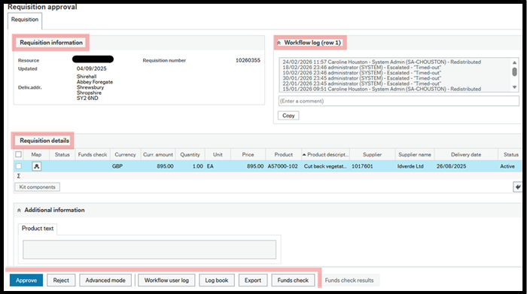

The Approval Task screen has four distinct areas:

Information Pane – This displays the main details about what the approval is for.

Workflow Log – This shows how the record has progressed through workflow with the details of who has actioned items and comments that have been added. Negative actions must always have a comment added in the Workflow Log.

Details Pane – This shows the full details for which the approval is being requested. For different types of approvals this may include multiple sections.

Action Buttons – The Action Buttons available on an approval screen will depend on the type of record, but the basic actions available to an approver will always have options to Approve (positive action) or Reject (negative action) the task, but they may have different names.

The following are some of the possible action buttons:

Approve - This is a positive action. Select Approve (or Task complete for some tasks) after checking all the request details to confirm and action.

Reject - This is a negative action. Select Reject (or Decline for some tasks) after checking all the request details and finding reasons to send back to the requester to amend or delete/cancel. This will create a task for the originator asking them to add the missing information. This may be a business requirement that is not actually a system mandatory requirement.

Advanced mode – Select Advanced mode to open the full request details and click back to Simple mode to Approve or Reject.

Simple mode - Select Simple mode to close from Advanced mode to view just the basic details and to Approve or Reject.

Withdraw Request – For some tasks you can select Withdraw request to cancel the form/request completely without it workflowing back to the requester.

Cancel Request - Select Cancel Request on rejection tasks, once the Workflow log comments have been assessed and it has been decided that the request needs deleting.

Resubmit - Select Resubmit on rejection tasks, once the Workflow log comments have been checked and actioned.

Close Requisition – Select Close Requisition to trigger a task allowing you to close a requisition from within the task.

Workflow user log – This opens the workflow comments log in a popup.

Log book – This is a summary of the Workflow log but without the Comments.

Export – This isn’t used by Shropshire Council.

Funds check – This produces a warning if the requisition is likely to exceed 90% of the available budget.

7.4.1 Other Approval Tasks

Supplier Invoice Approval Task - A supplier invoice is an invoice that has been sent into Proactis without a purchase order number and will only be accepted for specific areas of expenditure such as utility bills where it is not expected that an order will need to be created. A list of the exemptions can be found here.

Where this happens, the supplier invoice will be coded by the Payments Team and the approver will receive a Supplier Invoice approval task in which they will see the scanned image of the invoice within the task. They will check the price on the invoice or extra quantity received and if happy with this, approve the task.

If the invoice needs rejecting, the task can be rejected and the Payments team can then cancel the invoice on the system. If this option is chosen, action may need to be taken to resolve the issue with the Supplier directly.

Purchase Invoice Approval Task - If an invoice is received by Proactis where the invoice exceeds the value of the Purchase Order beyond the system tolerance (2.5% of the amount ordered, quantity delivered or amount delivered), the approver will receive a Purchase Invoice Approval task. In the approval task they will see the scanned image of the invoice and, in bold, where the difference lies.

Double approval shouldn't be needed (it will say Invoice control exceeded at the top of the page) meaning the tolerance has been breached. They will need to check what has been receipted and how many invoices there are already before deciding whether to approve or not. It should only be approved if the corresponding receipts match what is being asked to be approved. If the receipting doesn’t match, they shouldn’t be approving it before discussing with their team and making sure the goods or services have been received and receipted in the ERP.

Rejected Invoice Task - If an invoice is rejected, it will then go to the Payments Team as a Rejected Invoice Task. If the rejection relates to a miscode such as the invoice number contains a ‘l’ instead of a ‘1’ then the payments team will be able to correct this detail and redistribute the invoice back to the approver.

Sundry Supplier Check Invoice Approvals – The approver may receive tasks to approve or reject Sundry supplier invoices which are ‘one off’s from suppliers who are not in the system.

Goods Receipting

When you order goods or services in the ERP you should complete the Goods Receipt when the products are received.

If a Goods Receipt is not completed, 3-way matching cannot be completed, so the invoice will not be paid. You can part receipt and you can cancel the rest of the order to prevent further payment. You are Goods Receipting a Purchase Order. You can goods receipt before the invoice arrives or you can do it afterwards. If the invoice is registered first, you will receive a task showing an image of the invoice and requesting you to complete the receipt.

8.1 Receipting Goods

8.1.1 Enter a Goods Receipt

- Navigate to Procurement > Purchase Orders > Goods Received > Goods Receipt
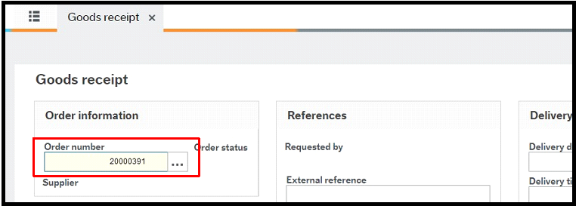

- Enter the PO number using type ahead or the lookup.
- Press [Tab]

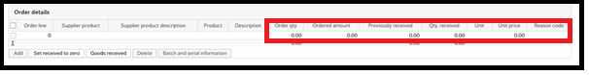

- Review / edit the product line:

Order qty – This is the total number of products ordered.

Previously received – This is the number of items already entered as a goods receipt.

Qty received – Enter the number of items to be received on this occasion. This cannot be greater than the Order qty minus Previously received but it can be less, which allows for partial delivery.

- For a multi-line order, you can:

- Check the delivery against each line
- Select all lines where the received quantity is the outstanding balance for the lines
- Click Goods received

This performs the Order qty minus Previously received calculation and enters the balance in the Qty received field for each selected line.

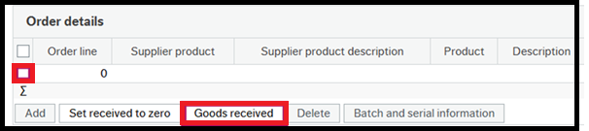

- Click on Save.

A success popup opens with the Receipt number. This number is not required.
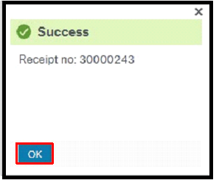

- Click OK.

8.2 Receipting Call-off Orders

Call-off orders are receipted In the same Goods receipt screen.

- Navigate to Procurement > Purchase Orders > Goods Received > Goods Receipt

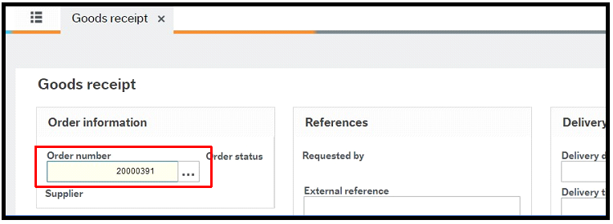

- Enter the PO number using type ahead or the lookup.

- Press [Tab]

- Review / edit the product line:

Order qty – This will be greyed out and cannot be edited.

Unit price – Enter the amount that you need to goods receipt in the Unit price.

- For a multi-line order, you can:

- Check the delivery against each line
- Select all lines where the unit price is the outstanding balance for the lines
- Click Goods received
- Click on Save.

A success popup opens with the Receipt number. This number is not required.

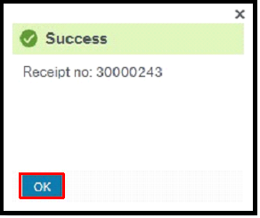

- Click OK.

8.3 Goods Return

If you have receipted an order but then decide that the goods are faulty or you are not happy with the service you can do a Goods return. This will prevent payment of the invoice unless it has already been paid, in which case the supplier will provide a Credit Note.

- Navigate to Procurement > Purchase orders > Goods received > Goods return

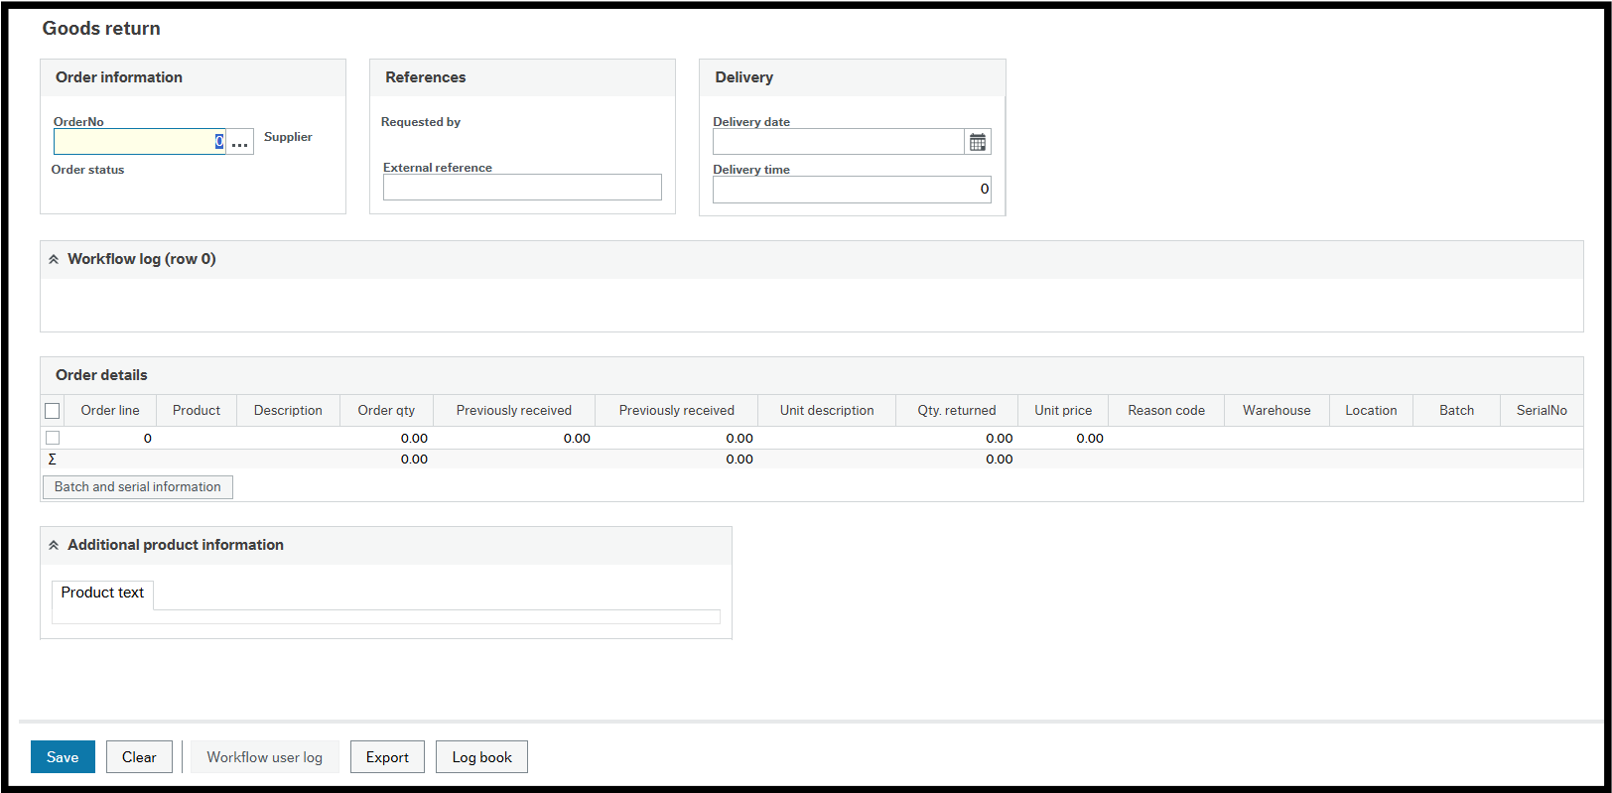

- Enter the Purchase Order number and press [Tab]
- Enter the amount to be returned in the Qty returned field and press [Tab]
- Click Save

8.4 When a Requisitioner Leaves

When a requisitioner is leaving their position, all orders of theirs that are outstanding or open need to be dealt with before they leave.
They must ensure that any requisitions which haven't been approved get closed, any outstanding purchase orders need to be receipted where possible and any old orders that are not due to be matched with an invoice need to be closed before they leave.

9.Invoice Processing

9.1 Purchase Order Invoices

9.1.1 Invoices for Shropshire Council / Marches LEP / Pension Fund

The Supplier will receive the Order which will state that they should send the Invoice electronically in a pdf format to shropshirecouncil.invoices@proactiscapture.com.

The invoice should clearly state the eight-digit purchase order number (that begins with a 2) that you've created.

Only one pdf should be submitted per invoice, but multiple pages and supporting documentation can be included within the same pdf document. Multiple pdfs can be sent to the Proactis email at the same time.

If the Supplier sends the invoice directly to Proactis, the invoice will be processed into the ERP and paid on the due date, if there are no discrepancies.

If the Supplier sends the invoice to the requisitioner, the requisitioner will need to send the pdf document to shropshirecouncil.invoices@proactiscapture.com. This will then be processed into the ERP.

Approximately five minutes after submitting your email, you should receive a receipt from Proactis confirming that your invoices have been submitted.

If you send an invalid attachment to the Proactis email address, an email notification will be sent back to the person who has sent the invalid attachment informing them of this.

9.1.2 Invoices for Star Housing

The Supplier will receive the Order which will state that they should send the Invoice electronically in a pdf format to starhousing.invoices@proactiscapture.com .

The invoice should clearly state the eight-digit purchase order number (that begins with a 2) that you've created.

Only one pdf should be submitted per invoice, but multiple pages and supporting documentation can be included within the same pdf document. Multiple pdfs can be sent to the Proactis email at the same time.

If the Supplier sends the invoice directly to Proactis, the invoice will be processed into the ERP and paid on the due date, if there are no discrepancies.

If the Supplier sends the invoice to the requisitioner, the requisitioner will need to send the pdf document to starhousing.invoices@proactiscapture.com . This will then be processed into the ERP.

9.2 Supplier Invoices

All invoices sent to Proactis (shropshirecouncil.invoices@proactiscapture.com or starhousing.invoices@proactiscapture.com) should relate to a purchase order in the ERP. If you have already provided the Supplier with a PO number and they have just omitted it from the Invoice, advise them of the PO number and ask them to resubmit a new invoice with the PO number included on it. If you omitted to raise a PO for this order, retrospectively raise a PO number and provide this to the Supplier (need to ensure the supplier does not think this is a further order to supply the goods/service again), to include on the invoice and resubmit the invoice.

A supplier invoice is an invoice that has been sent into Proactis without a purchase order number but with the Supplier ID, Account Number and Cost Centre written clearly on the invoice. Supplier invoices will only be accepted for specific areas of expenditure such as utility bills.

9.3 Manual Payment Request

To make a payment to a supplier without an invoice please use the manual payment request form.

These forms are used in instances such as:

- When a grant payment is made to a supplier and we haven’t received an invoice from the supplier
- To enter a credit against a supplier without receiving an official credit note
- Emergency payments to a supplier where an invoice hasn’t been received

Once you've populated this form it will need to be saved as a pdf and sent to the shropshirecouncil.invoices@proactiscapture.com email address or starhousing.invoices@proactiscapture.com for Star Housing.

If you have supporting documentation that needs to be included with the manual payment request form, please include this as part of the same pdf document. You must not submit a separate pdf for the payment request form and then a separate pdf for the supporting documentation.

After it has been processed through Proactis by the AP team it will workflow to the authoriser of the cost centre to approve in the ERP.

9.4 Proactis Guidelines

PDF documents can only be processed if they meet the following criteria:

- PDFs must be 1 PDF to 1 invoice / credit, as each file is treated as a new document
- The PDF must not have security applied, as these cannot be read by the system
- Documents other than invoice / credit related PDF files (for e.g. T&C’s, statements) should not be sent to the dedicated email address
- The PDF must be attached to the original email and not embedded as part of a forwarded email
- The dedicated inboxes are not manually monitored and therefore supplier queries or questions etc. will not be dealt with
- It is highly recommended that any scanned PDF documents are of a minimum resolution of 300dpi. This helps to ensure consistent and accurate extraction of data from the images

The PDF file size should be kept as low as possible, typically less than 150KB to reduce the reliance on bandwidth usage and to speed up processing.

The system will not accept any other format of documents such as JPG and TIFF.

As this mailbox is not monitored, any emails that are sent to the mailbox that do not have any attachments or incorrect format will not be returned and will be deleted after 30 days. Senders of emails without valid attachments, will receive a notification informing them of this.

9.5 Viewing Invoices Images

Images of invoices received by Proactis can be viewed by using the Budget Holder report GL Enquiry (Reports > Finance & Procurement > Finance > GL Enquiry) which you can search on and drill down into the Invoice image for the Cost Centres that you are responsible for. If you aren’t a budget holder but need access to Budget Holder reports as a subscriber, you will need to ask the budget holder to email the Systems Team on erp@shropshire.gov.uk and request that you have subscriber access to budget reports for their cost centres. They will need to confirm the resource ID, position number and the cost centres that they will need to have access to.

10.New Product Requests

If you have a requirement for a product that is not currently available in the ERP, you can request that it is added to the Product Master File using the Purchase Product Request form. Forms are used where requests have to be evaluated before data is entered into the ERP. In the case of new products, the evaluation is carried out by Procurement.

10.1. Purchase Product Request Form

- Navigate to Forms > Finance > Purchase Product Request

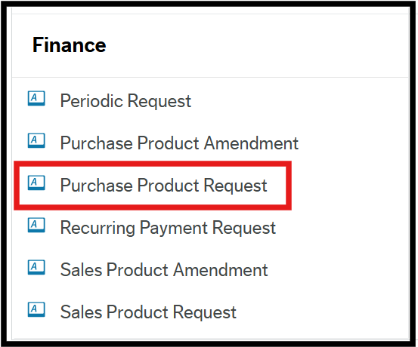

This form has five separate sections to be completed.

10.1.1 P2P Product Request Form Section

Form ID - The system generates this number when you submit it or save it.

Form description - Enter a description to describe what it is for and make it easier to find.

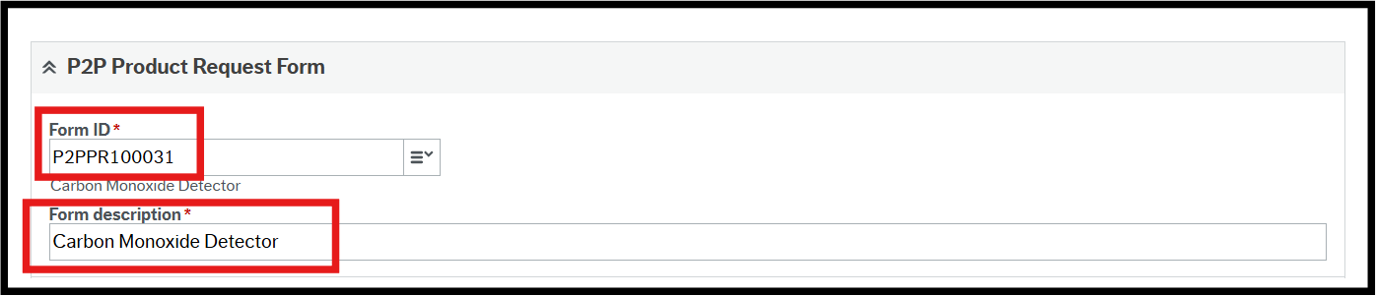

10.1.2 New Product Request Section

Name of new product - Enter the product name.

Product Group - Press SPACEBAR to select from the lookup.

New Product ID – This is completed by Procurement.

Preferred Supplier – Enter the supplier name.

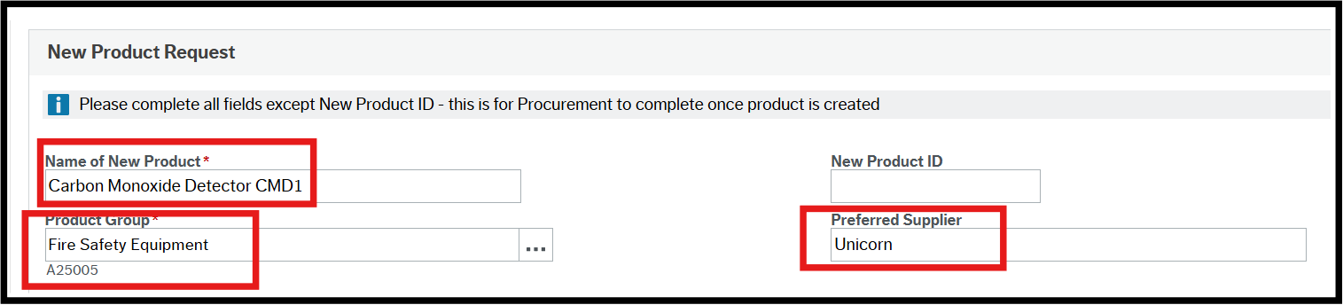

10.1.3 Product Setup Section

Unit - Press SPACEBAR to select from the lookup.

Purchase Price – Enter the purchase price.

Purchase Tax Code – Press SPACEBAR to select from the lookup.

Amount Use? – Leave blank.

Effective Date – Enter the date the product is wanted.

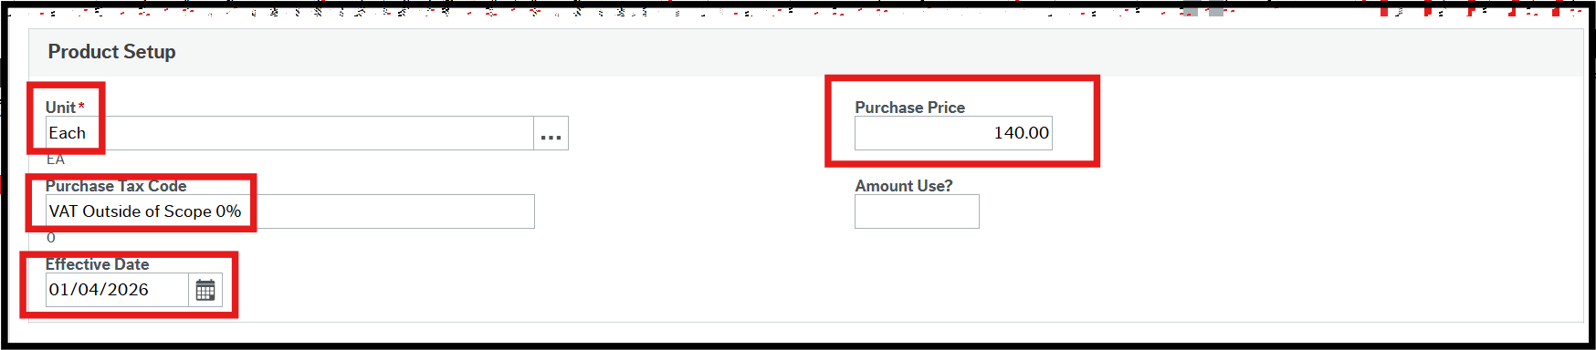

10.1.4 Product Information

Product Hierarchy – This is completed by Procurement.

UNSPSC Category – Press SPACEBAR to select from the lookup.

Technical Approval – Press SPACEBAR to select from the lookup.

ProClass Category – Press SPACEBAR to select from the lookup. This field is used for reporting purposes.

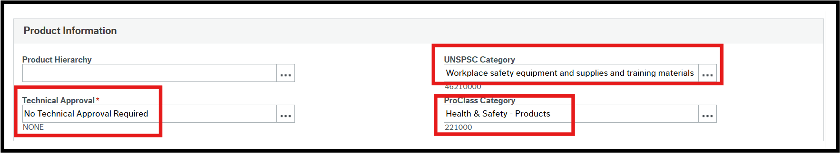

10.1.5 Reason Section

Reason – Enter the reason why this product is needed.

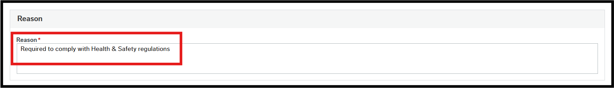

10.1.6 Action Buttons

Clear - Clears the contents of the form.

Print preview - This isn’t used by Shropshire Council.

Submit form - Sends the form into workflow for approval.

Save as draft - This saves the form without sending it into the workflow.

Export - This isn’t used by Shropshire Council.
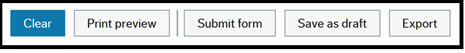

If you select Save as draft, the Success popup will open.

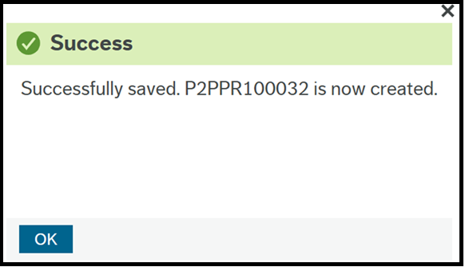

1. Take a note of the number as it will be needed to re-open the form.
2. Click OK.
If you select Submit form, the Success popup will open.

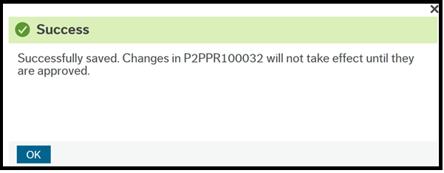

3. Take a note of the number as it will be needed to re-open the form.
4. Click OK.

When the product has been created in the Product Master file the originator is notified by email that the product is available for use.

11. Own Requisitions

Requisitioners have access to an enquiry called “Own requisitions”. This enquiry is very useful as it allows the following:

- Access to open your requisitions by clicking on the Requisition number.
- Shows the Workflow status of your requisition, either in workflow or finished.
- Where status is Finished, a Purchase Order number will be present and you can click on it to open the purchase order.

Navigate to Main Menu > Procurement > Requisitions > Enquiries > Own Requisitions.

To check what stage of Workflow your requisition is at and who the task owner is, you need to use your Workflow Enquiry – Requisitions.

Navigate to Main Menu > Procurement > Requisitions > Enquiries > Workflow Enquiry – Requisitions.

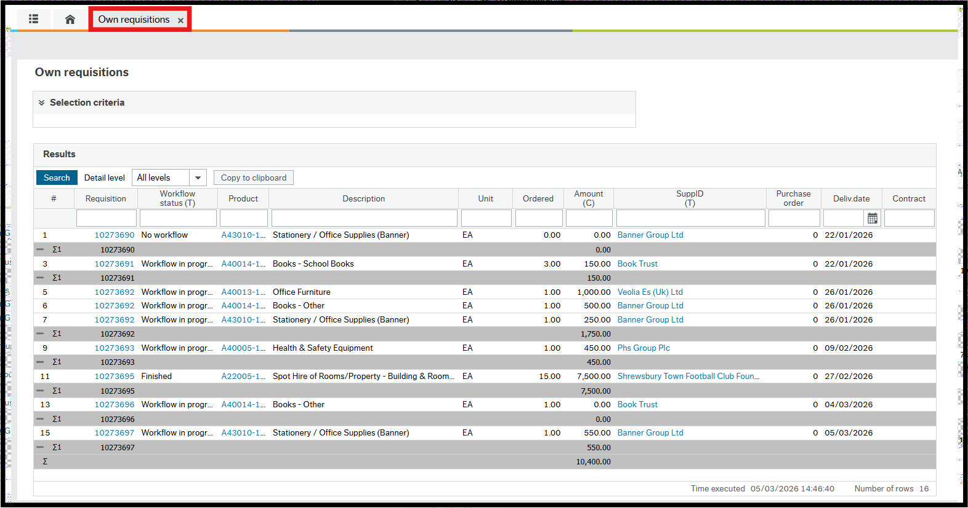

11.1 Your Purchases

Another useful enquiry is called Your purchases. This shows you the complete lifecycle of your orders.

Navigate to Main Menu > Procurement > Requisitions > Your purchases
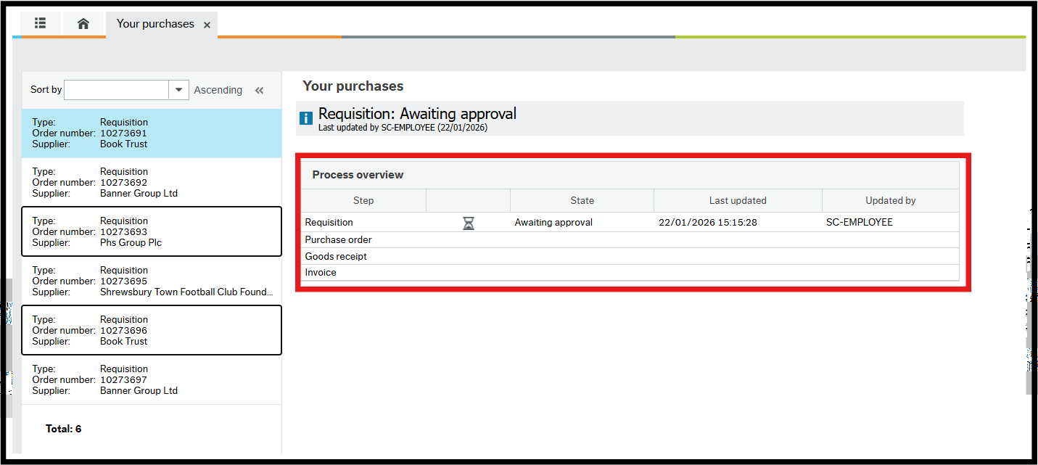

12. New Supplier Request

If you have a requirement to use a supplier that is not currently available in the ERP, you can request that it is added to the Supplier Master File using the Supplier screen. When saved, the request is workflowed to Procurement for assessment and approval.

12.1. Supplier Request Process

If you have identified a good/service that you wish to purchase from a supplier, you will first need to check if the supplier currently exists on the system.

Navigate to Main Menu > Procurement > Supplier information > Suppliers

Type in your supplier name in the Lookup box to see if it exists. To be certain that the supplier does not already exist in the ERP, it is advisable to check by an unique identifier such as Companies House number or bank details.

If the supplier does not exist on the system, you should liaise with Procurement on procurement@shropshire.gov.uk to ascertain whether you can purchase the specified goods/services from this new supplier. Procurement will either confirm that this is OK, or they may advise you to use another supplier that the Council has a corporate contract with and is currently on the system that will be able to provide this type of good/service.

If Procurement recommend a corporate supplier instead, then the user can go straight to the requisitioning/ordering stage and place an order with the recommended supplier.

If Procurement accept that a new supplier can be used for this good/service, the user will be required to send the Supplier Creation Form to the new supplier and ask them to populate it and send it back to the user to start off the process of setting up the supplier on the system.

Discuss the requirement with Procurement.

Send the Supplier New Supplier Creation Form to the supplier and state that an order can only be placed once the supplier has completed the form and sent it back to them to update the supplier details on the system.

The form is attached to the supplier record that you have created once all of the details have been entered.

12.2 Supplier Search

The Supplier Master File (SMF) is used to lookup supplier details, supplier group access permitting. Suppliers are split into groups, some of which are sensitive and therefore access is limited. To search for a supplier, you must:

1. Navigate to Main menu > Procurement > Supplier information > Suppliers.
2. Click on the drop-down arrow to the right-hand side of the Lookup field then click Value lookup.
3. Search using any of the criteria available, for instance Name or VAT registration number. You can use a wildcard * if you’re not sure of the exact name that a supplier could have been created under for instance *Book* would return all suppliers with the word Book in its name. You can enter criteria in multiple fields if you use the Advanced search option.
4. Click Search button to display any results matching your criteria.

12.3 New Supplier Request

Navigate to Main Menu > Procurement > Supplier information > Suppliers

The Supplier screen opens.

Enter any part of the Supplier name in the Supplier Lookup field.
- If it matches any part of any Supplier’s name it will appear in a popup. If the Supplier you are trying to create is in the popup, click on it to populate the screen with the existing details.
- If there are no matches for the name, check with different spellings or a different part of the name to ensure they do not exist in the ERP already. A tooltip will appear saying No matching values found if the Supplier does not exist with the details entered.

Click New.
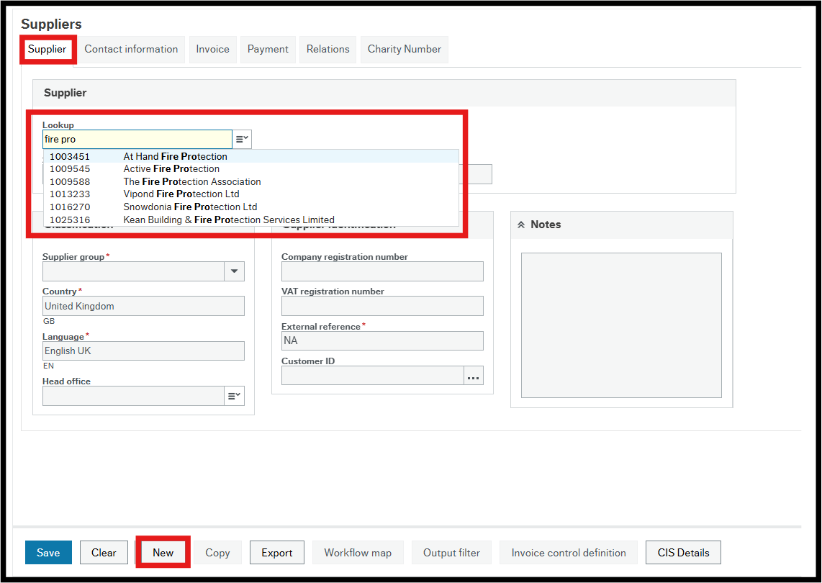

The Supplier window has five tabs at the top of the screen:

Supplier – This contains the Classification and Supplier identification details.

Contact information – The supplier’s address and contact details.

Invoice – The invoicing terms applicable to the Supplier.

Payment – This contains the payment and bank details for the Supplier.

Relations – The reporting and action relations for the Supplier.

Charity Number – This contains the Charity Number if applicable.

12.3.1 The Supplier Tab

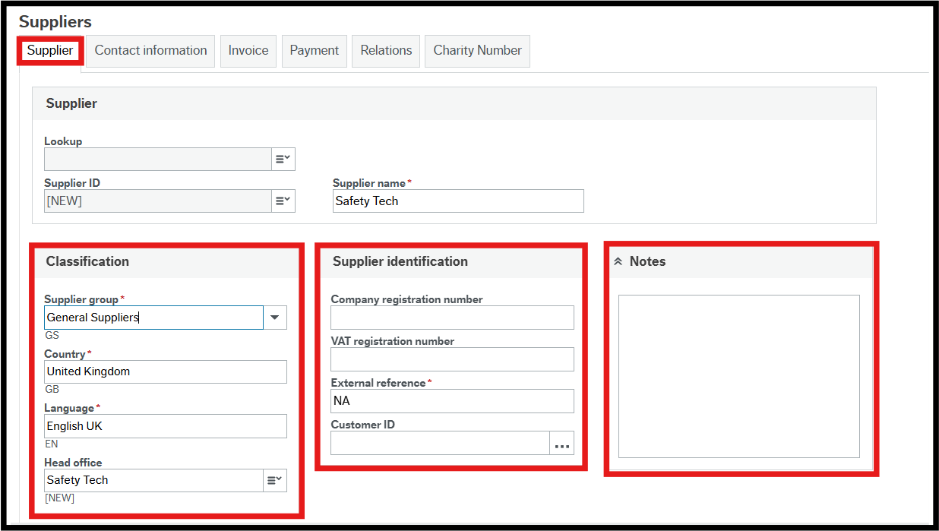

In the Classification section:

Supplier group – Select from the drop-down.

When you create a supplier in the system, there are a number of different Supplier Groups available to choose from, with the most commonly used being the General Supplier (GS) Group.

Below is a table of other available Supplier Groups to choose from. Please note you will only have access to the groups that relate to your service area. For example, if you work in Social Care you will be able to see the Adult Care Services Supplier Group but users from other service areas will not.

Supplier  Group | Supplier Name | Note
GS | General Supplier
AC | Adult Care Services | Only Social Care teams would set these suppliers up
CC | Children’s Care Services | Only Social Care teams would set these suppliers up
CT | Public Corporations & Trading Funds
CV | Charities & Voluntary Sector
EM | Resources – Employees | Only HR/Payroll would set these suppliers up
EN | Resources – Non Employees | Only HR/Payroll would set these suppliers up
GB | Central Government / Government  Bodies
IR | IR35 Non Resources Employee
IS | Internal Supplier | Only Sys Admin /  Procurement would set these suppliers up
LA | Local Authorities
NE | NHS England
NO | NHS Other
PS | Payroll Supplier | Only HR/Payroll would set these suppliers up
SS | Sundry Supplier | Only the Payments Team would set these suppliers up

Country – This defaults to the United Kingdom. To change it use type ahead and then select the country from the drop-down.

Language – This defaults to English UK. To change it use type ahead and then select the country from the drop-down.

Head office - This defaults to the Supplier name but can be changed.

In the Supplier identification section:

Company registration number – Enter if applicable.

VAT registration number – Enter if applicable.

External reference – This is the reference in the legacy system. If it is a new customer, enter NA.

Customer ID – Leave blank.
In the Notes section:

Notes – This field is not used on creating a supplier but can be used when the account is active for such things as insolvency or bankruptcy details.

12.3.2 The Contact Information Tab

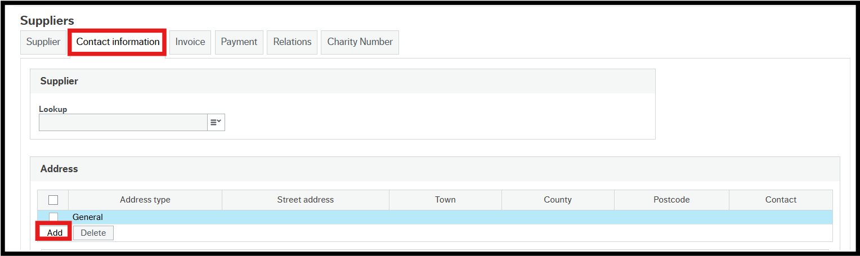

Select the Contact Information tab.

Click Add to create a new address.

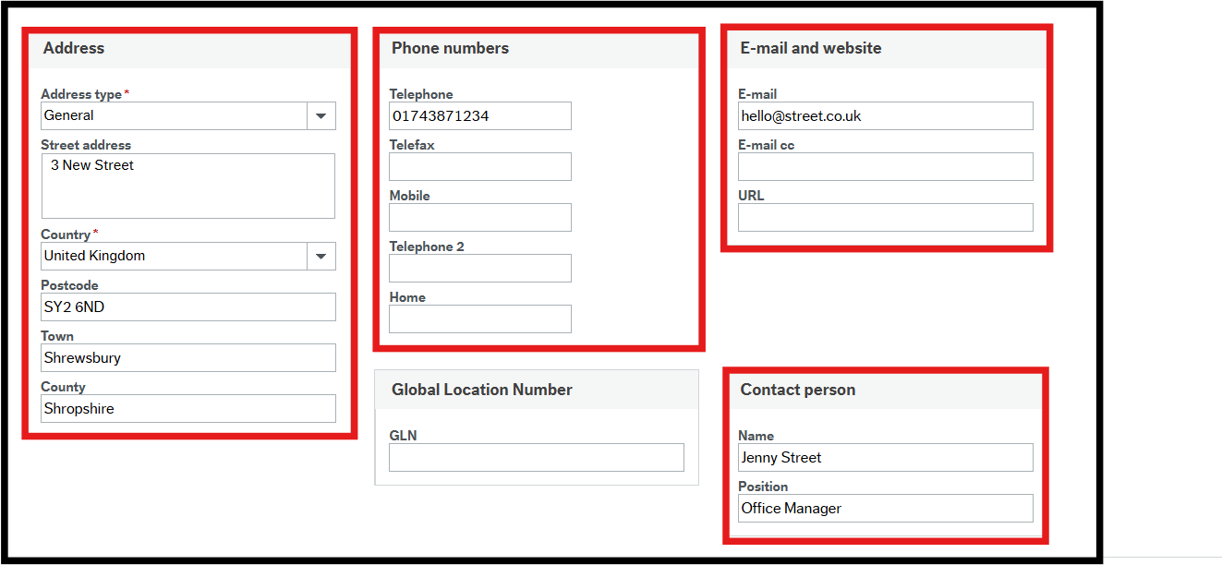

In the Address details section:

Address type – Select the type from the drop-down.

Street address – This is the number/name and street name only.

Country – The default is the United Kingdom but can be changed using the drop-down.

Postcode – Enter the postcode.

Town – Enter the town.

County – enter the county.

In the Phone numbers section, enter the all the telephone details that you have.

The European Article Numbering section is not used.

In the Email and website section enter all the relevant details that you have.

If a supplier has sent an email address for where they would like their orders and remittances to be sent this should be added as a General supplier address. If the supplier has sent different emails for where they would like their order and remittances to be sent then the order email address can be added as the General email address and the remittance email address will need to be added as a Payment email address.

In the Contact person section:

Name – Enter the name of the person to contact in the Supplier’s organisation.

Position – The contact person’s position in the Supplier’s organisation.

12.3.3 The Invoice Tab

This tab is populated by Procurement / AP.

12.3.4 The Payment Tab

Select the Payment tab.

Enter the Account Number, Account Name and Sort Code under Bank details making sure you don’t use any hyphens. Complete other applicable fields, if appropriate.

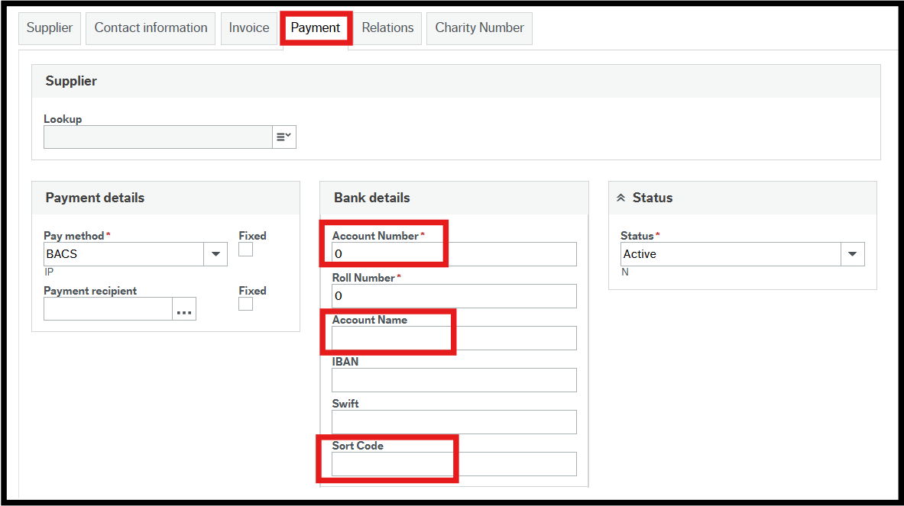

12.3.5 The Relation Tab

Select the Relations tab.

In the relations tab the user will have to populate any data here that they have received in the Supplier Creation Form that has been returned to them so this could include:

Supplier group – This is populated from the Supplier Group selected previously.

Whole of Government Account Code - Applicable to public sector organisations only. If the supplier doesn’t provide the user with this detail then this section can leave it blank.

Small or Medium Enterprise – Select Y or N. If the supplier doesn’t provide the user with this detail then this section can leave it blank.

Publish Spend – Press SPACEBAR to bring up a list of options and use type ahead.

Supplier visible to Council Staff – If you work directly for the Council you will have to enter a Y in this field, otherwise you will be unable to see the supplier once it has been created.
If you work for a School or for STAR Housing you will have to enter an N in this field.

Types of Business - If no information has been provided on the new Supplier Creation form, you can enter NA here.

SIC Code – If no information has been provided on the new Supplier Creation form for Supplier Standard Industry Classification, you can enter N/A here.

Shropshire Area Supplier – Select Local, Not Local or Trading within Shropshire. If the supplier doesn’t provide the user with this detail then this section can leave it blank.

IR35 check required - You must select Yes or No using the information the team leader or manager has provided on the new Supplier Creation form Internal use only page.

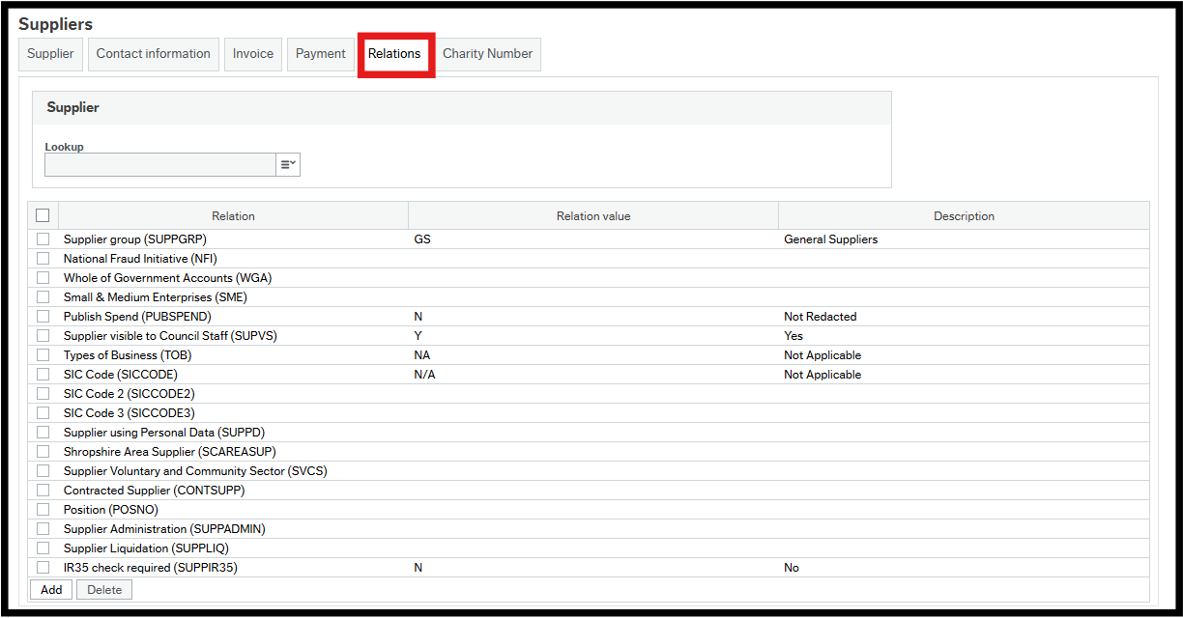

12.3.6 The Charity Number Tab

Select the Charity Number tab.

If the new supplier is a charity, enter their number in the Charity Number field.

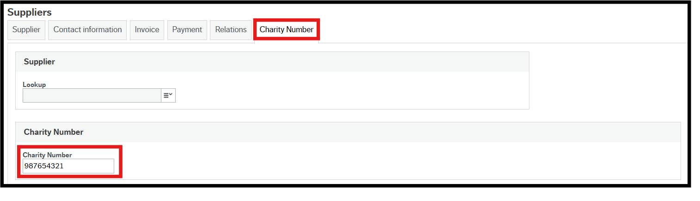

12.3.7 Complete the process

When all the new Supplier’s details have been entered you can click Save.

A Success popup will then appear but it is important to note that a task will then be rerouted to yourself within a minute. This task will require you to then attach the Supplier Creation Form that the supplier completed and that you have used to populate the details.

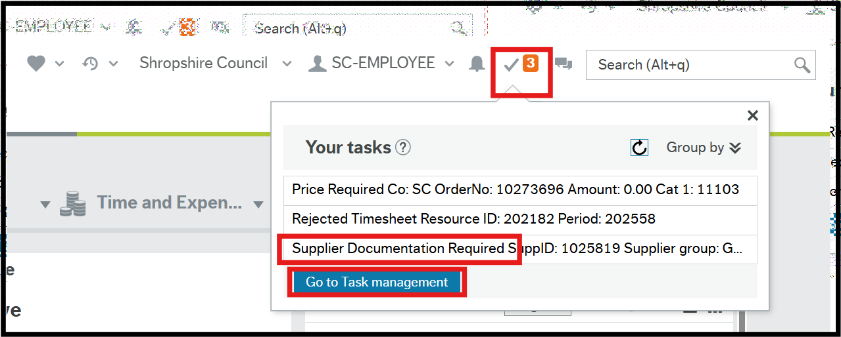

You will have to Go to Task management and click on the Supplier Documentation Required task and then click on the Paperclip icon in the top right hand corner to attach the Supplier Creation Form.

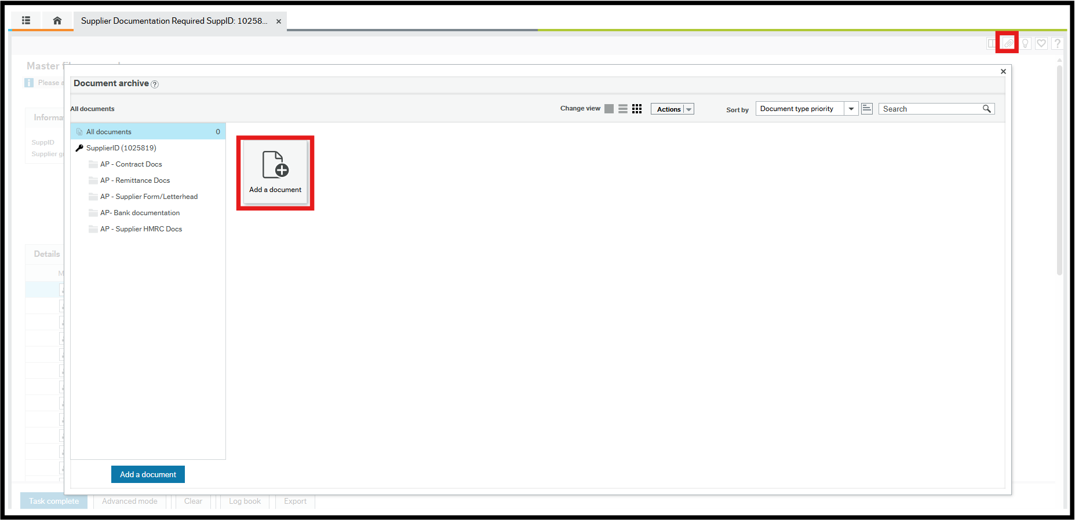

Once you have done this you can click on the Task Complete button in the bottom left hand corner.

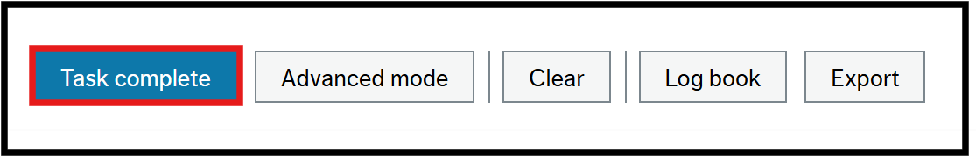

The supplier creation will then be workflowed to Procurement to be approved if a Council member of staff has requested to set up the supplier before going to the AP team to verify that the data and correct bank details have been included.

If a schools or Council member of staff has requested to set up the supplier this will be workflowed directly to the AP team to verify that the data and correct bank details have been included.

12.4 Workflow enquiry

As with requisitions you can do a Workflow enquiry for new supplier requests.

1. Navigate to Main Menu > Procurement > Supplier information > Enquiries > Workflow enquiry – Supplier.
2. Click on the Workflow map icon to the left of the supplier you want to enquire on.

You will now see the relevant workflow map.

