Jequirity bean bracelets - alert
You may be aware of an alert regarding the sale of the above bracelets that have been on sale at Eden Project in Cornwall and another 36 retailers across the UK; urging customers to return the red and black bracelets made from the Jequirity bean, the deadly seed of the plant abrus precatorious.
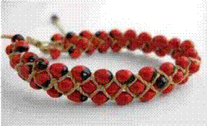
The Health Protection Agency (HPA) has provided the following information:
The HPA’s position is that: "The National Poisons Information Service (NPIS), which is commissioned by the Health Protection Agency, has been made aware that bracelets are being sold in the United Kingdom that may contain seeds from the plant Abrus precatorius. Seeds from Abrus precatorius contain the poison abrin which is very toxic. Ingestion of any quantity of chewed, crushed or drilled (e.g. from a necklace) seeds should be regarded seriously because, if fully absorbed, even small amounts of abrin can be fatal.”
"However, seeds are not expected to cause serious problems if swallowed whole and not chewed.
"There may be a delay of up to three days before symptoms e.g. vomiting, abdominal pain or diarrhoea occur. Anyone who is suspected of ingesting seeds from this plant should seek medical advice immediately.
“Advice has been issued urging customers to return the red and black bracelets made from the Jequirity bean to suppliers - people who have bought the bracelets are being urged to bag them and then wash their hands and avoid touching their eyes.
“Bracelets containing Jequirity bean, (abrus precatorious) are not particularly harmful in their natural state. However, if the supplier cannot be identified, then it would be prudent to ensure that the bracelets are securely bagged and disposed of safely through normal household waste disposal procedures. As an additional precaution, owners should also wash hands and avoid touching eyes after bagging.”

