**How do I create a Recurring Payment in Business World?**

The Recurring Payment facility allows you to pay an expected regular amount to a supplier on a scheduled basis.

If you would like to make use of this facility, you will have to complete the Recurring Payment Form in Business World which falls under Forms>Finance>Recurring Payment Request and do the following.

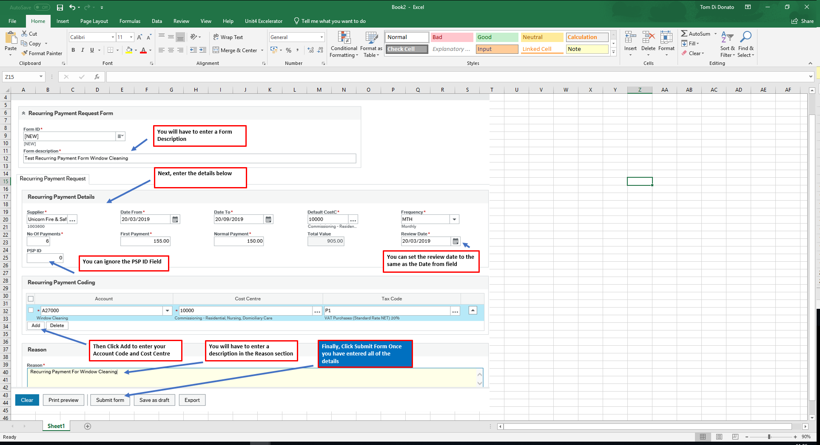

Once you have submitted the form you will get a message saying it was successfully submitted.

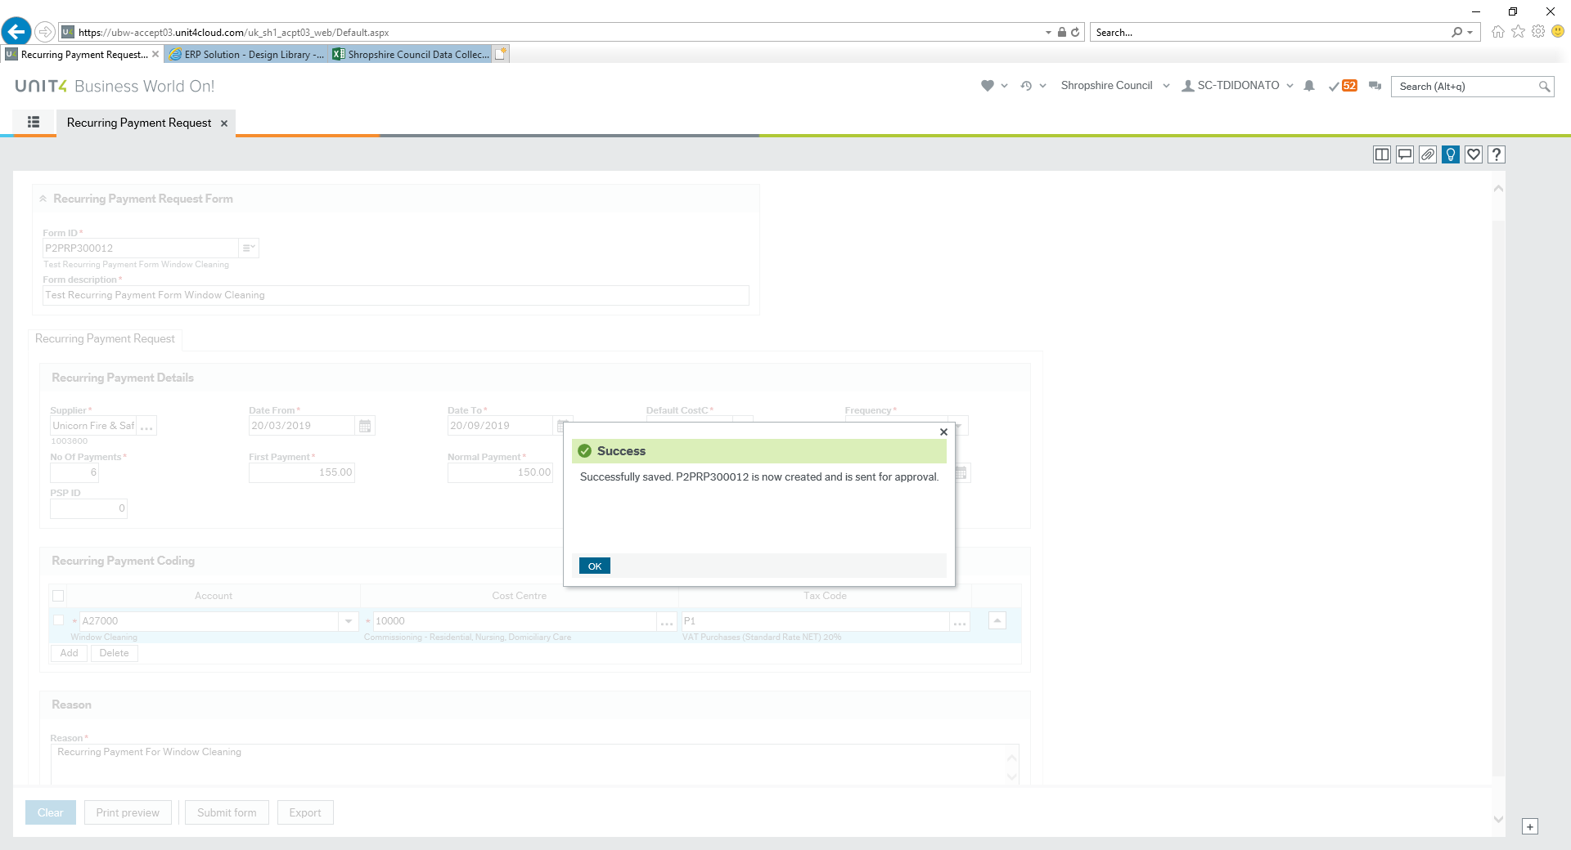

You will still be in the same screen but now the Form ID P2PRP3000012 will be defaulted into the top left hand corner. You will need to add any supporting documentation such as an invoice for the months you’ve defined and you can do this by clicking on the paperclip icon in the top right hand side of the screen and adding your attachment. This will be automatically saved to the form once you have added it and the paperclip symbol will show as a dark blue colour. You won’t have to resubmit this form.

If you do close the form and would like to add your attachment, you can go back to Forms>Finance>Recurring Payment Request and then in the Form ID box you can remove the ‘NEW’ text and then press space and you will be able to click on the form you have just created and then add your attachment.

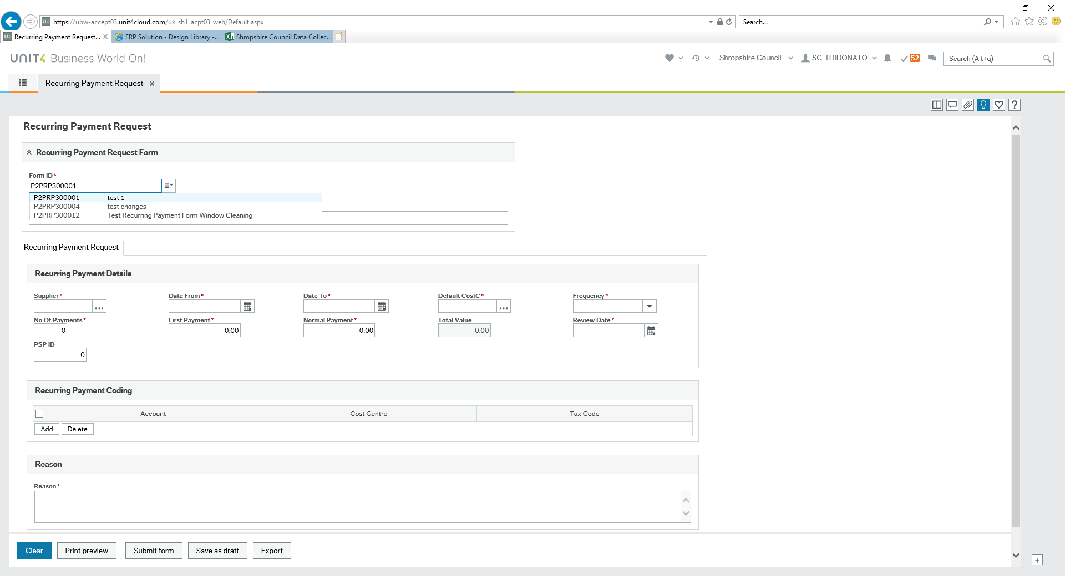

Once your form is submitted, it will then be workflowed to the authoriser of the Cost Centre to approve. Once approved, this will then get processed by the Accounts Payable Team and a notification will be sent once it has been activated.