Push and Pull Factors Template

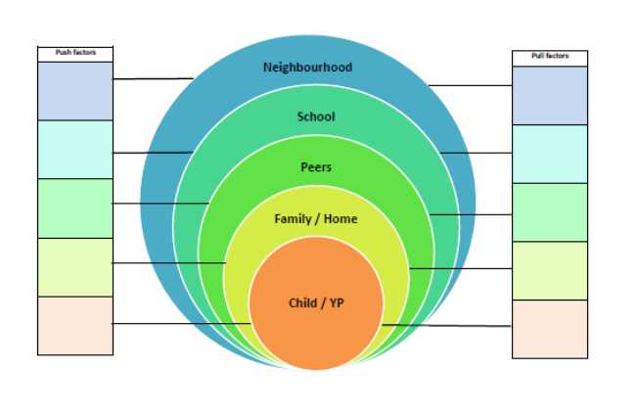Taken from Collaborative Working to Promote Attendance and Psychological Wellbeing – Solihull Community EPS