Display Screen Equipment Arrangements

Contents:

1. Statement of purpose/objectives
2. Scope
3. Display Screen Equipment (DSE) and workstation risk assessments
4. DSE Workstations
5. Use of portable DSE
6. Definition of DSE
7. New Ways of Working
8. Information, instruction, and training
9. Implementation
10. Compliance
11. Review of Arrangement

1.0 Statement of purpose/objectives
This arrangement will assist in meeting Shropshire Councils objective to care for staff and meet the legislative requirements. The main health risks associated with DSE are musculoskeletal disorders, stress and visual fatigue. Whilst the risk to individual users is often low, they can still be significant if good practice is not followed.

2.0 Scope
This procedure applies to all Shropshire Council (SC) employees including part time, temporary staff and volunteers who use Visual Display Units (VDU)/Display Screen Equipment (DSE).

3.0 Display Screen Equipment (DSE) and Workstation Risk Assessments
The Council has a duty to ensure that an assessment of risk from DSE and workstation to the health and safety of employees is undertaken. This will be carried out by the employee if they have access to the intranet or the internet (using the Cardinus Healthy Working). The DSE assessment will also include an assessment of the work environment and furniture/equipment. The assessment should be reviewed annually or sooner if it is no longer valid. A record of the risk assessment can be retained by the User.
4.0 Display Screen Equipment Workstations
All DSE workstations must meet the minimal standards, this will be verified by the analysis of the workstation to assess and reduce risk. Only workstations that have had a satisfactory DSE workstation risk assessment may be used.

5.0 Use of Portable DSE
The use of laptops, notebook computers/PDA’s and similar portable equipment has increased considerably. All users of this equipment must have sufficient training to enable them to recognise and avoid risk factors when setting up and using their portable DSE.
Laptops must not be used for prolonged periods at the employee’s main place of work without the use of a separate keyboard and mouse or a docking station.

6.0 Maintenance of DSE
All DSE should be routinely maintained, this includes portable electrical testing and the visual inspection of cables to ensure good cable management is practiced. DSE users should carry out checks of peripheral equipment, seating, and the cleaning of the monitor screen, keyboard & mouse when required.

7.0 New Ways of Working
Shared workstations should be analysed and assessed for each DSE user. Home workers must also complete DSE assessments, and these employees should be suitably trained to carry out their own DSE risk assessment.

8.0 Information, Instruction and Training
The employer has a duty to provide adequate information, instruction, and training to employees. All DSE users should receive appropriate training in the use of their Visual Display Unit VDU/DSE. This training will allow DSE users to carry out their own DSE workstation risk assessment(s).

9.0 Implementation of the DSE Arrangement
Management guidance in the form of Frequently Asked Questions will be provided and updated to support the implementation of the DSE arrangement.

10.0 Compliance
This arrangement will enable Shropshire Council to conform to the statutory requirements and best current practice. Further references are provided in Appendix 2

11.0 Review of Arrangement
This arrangement will be reviewed every three years or if legislative changes occur. This will be carried out by the Health and Safety Team, in consultation with recognised trades unions.

Approving Body
Consultation - Health, Safety & Welfare Group April 2008
Approved - Health & Safety Forum Oct 2008
Reviewed - HR&D (Safety Team) March 2010
Reviewed - Health, Safety & Welfare Group April 2012
Reviewed - Health & Safety Team January 2018
Reviewed - Health & Safety Team September 2021
Reviewed - Health & Safety Team July 2023

Display Screen Equipment Frequently Asked Questions

Contents:

- Roles and Responsibilities
- What does DSE stand for?
- Who is a DSE user?
- What is a DSE assessment?
- Who should carry out my DSE assessment?
- When and at what frequency should I complete the online DSE Workstation training and risk assessment package, Cardinus?
- I do not have access to the intranet, how can I carry out a DSE assessment?
- What does ‘ergonomic mean’?
- Does my computer affect my health?
- What is a workstation?
- What is a docking station?
- When should I use a docking station?
- What training is available?
- How can I have an eye and eyesight test?
- Where do I obtain an eye test?
- What is ‘Cardinus?
- Can working with DSE affect my eyesight?
- Do VDU’s give out harmful radiation?
- I use a laptop – are there any precautions I should take?
- Is it true that using a mouse can cause problems?
- What are the minimum standards for a DSE workstation?
- Is there a minimum legal desk size?
- What should I do if I have any concerns with my workstation?
- What is ‘Work related upper limb disorder’ (WRULD)?
- What is ‘Musculoskeletal disorder’ (MSD)?
26. What is a Sit/Stand desk?
27. How do I obtain a sit/stand desk?
28. As a DSE User, what actions should I take if I am pregnant or have epilepsy?
29. How do I adjust my chair?
30. What do we do for Agency workers?
31. Where can I go for further advice?

1.0 Roles and Responsibilities
1.1 Shropshire Council as an employer, through its elected members, has ultimate responsibility for compliance with health and safety legislation.

1.2 The Chief Executive and Corporate Directors are responsible for ensuring:

- That adequate resource is available for the implementation and management of safe display screen equipment in use at all workplaces.
- Corporate Directors will ensure adequate arrangements are in place monitoring safe working practice
- That the safe management of display screen working is promoted.

1.3 Area Directors / Heads of Service shall be responsible for:

- The safe management of display screen equipment working in respect of workplaces under their control and in full compliance with all relevant legislation and Approved Codes of Practice (ACOP)
- The nomination of sufficient and appropriately trained employees to whom the function of “Display Screen Assessor” are available at workplaces.

1.4 Line managers are responsible for:

- Identifying all Display Screen users within their teams and maintaining records of DSE users
- Ensuring that all DSE workstations within their team comply with minimal statutory requirements
- That all DSE users are trained in the correct use of DSE equipment

- Ensuring that sufficient DSE workplace assessors are available to support employees where necessary
- Ensuring all DSE workstation risk assessments within their teams have been completed and are reviewed as necessary and at least annually

1.5 All Employees

Employees of the Council have general duties under health and safety legislation
In relation to display screen equipment (DSE) working, their duties can be summarised as:-

- To comply with the requirements of the DSE arrangements and associated safe systems of work.
- Complete the online interactive Cardinus DSE Workstation training and risk assessment if appropriate

2.0 What does DSE stand for?
Display Screen Equipment (DSE) means any alphanumeric or graphical display screen, regardless of the display process. For example, a computer or laptop

3.0 Who is a DSE user?
A user is an employee who normally uses DSE:

- for continuous or near continuous spells of an hour or more at a time,
- use DSE in this way more or less daily,
- have to transfer information quickly to or from the DSE,
- and also need to apply high levels of attention and concentration,
- or are highly dependent on DSE,
- Or have little choice about using it or need special training or skills to use the DSE.

4.0 What is a DSE risk assessment?
This is a risk assessment of the DSE and associated workstation area. It is a way to identify hazards in your work area and provide control measures to reduce or remove any residual risk.

5.0 Who should carry out my DSE assessment?
In the first instance self-assessment this is carried out by the DSE user at their workstation using the online Cardinus DSE Workstation interactive training and risk assessment.

6.0 When and at what frequency should I complete the online DSE Workstation training and risk assessment?
The online Cardinus DSE Workstation interactive training and risk assessment should be completed:
- By all DSE Users
- Annually
- If you have moved location/workstation
- Have requested to update your DSE risk assessment.
- Have health concerns or you’re pregnant

7.0 I do not have access to the intranet, how can I carry out a DSE assessment?
By discussing with your line manager in the first instance or contacting the Health & Safety team and request a hardcopy DSE checklist form

8.0 What does ‘ergonomic mean’?
Ergonomics is a science concerned with the ‘fit’ between people and their work. It puts people first, taking account of their capabilities and limitations.
Ergonomics aims to make sure that tasks, equipment, information, and the environment (which includes, noise, vibration, lighting, temperature and ventilation) suit each worker.

9.0 Does my computer affect my health?
No, it should not; training and a risk assessment can be provided by completing the on-line Cardinus DSE Workstation training programme or contacting the Health & Safety team.
If DSE work affects your health, this must be recorded on your risk assessment and reported to your line manager.

10.0 What is a DSE workstation?
A workstation exists wherever there is DSE (including portable DSE) in prolonged use. For all DSE the workstation as defined, is the assembly including the screen, keyboard, other parts of the computer and its accessories (i.e. mouse or other input device), desk, chair and the immediate work environment

11.0 What is a docking station?
Docking stations are a way to avoid many of the ergonomic disadvantages of using portable DSE (i.e. laptops) by allowing for example, the use of a full-sized screen, keyboard and mouse.

Other systems include the use of raiser blocks to enable the portable computer’s own screen to be used. The docking station should allow the user to achieve a comfortable working position allowing some variation in posture and having sufficient space for documents and anything else needed for their work tasks.

12.0 When should I use a docking station?
A docking station should be provided when portable DSE (i.e. laptops) are in prolonged or repeated use. Or alternatively the use of a separate keyboard and mouse may be considered subject to the outcome of the DSE risk assessment

13.0 What training is available?
All employees with intranet/internet access should carry out the Cardinus DSE Workstation interactive training and risk assessment. Corporate DSE training courses can be accessed by contacting the Health and Safety Team.

14.0 How can I have an eye and eyesight test?
Designated users of DSE are entitled to appropriate free eye and eyesight tests, line managers should follow the guidance provided in the employee handbook.

15.0 Where do I obtain an eye test?
In the first instance contact your line manager for details or look at the Eye Test Policy.

16.0 What is ‘Cardinus?
Cardinus comprises of an interactive workstation safety training and self-risk assessment package available to all intranet users. It provides the opportunity for staff to take immediate action to address workstation issues where possible.
The training concludes with a short multi-choice test. DSE users then complete their own risk assessment. On completion of the risk assessment, users are then presented with an action report detailing the measures required to rectify any issues raised.
The database allows for scheduled e-mails to remind employees to complete the training/risk assessments or other specific tasks allocated.

17.0 Can working with DSE affect my eyesight?
Extensive research has found no evidence that working with DSE causes disease or permanent damage to eyes or eyesight, but it may make users with pre-existing vision defects more aware of them. Using DSE for long periods without a break may lead to tired eyes/discomfort, it is important to ensure adequate breaks are planned and that DSE training & risk assessment has been carried out.

18.0 Do DSE/VDU’s give out harmful radiation?
No. DSE/VDU screens give out visible light, which allows us to see the screen. Other forms of electromagnetic radiation are emitted but these fall well below internationally excepted safety levels.

19.0 I use a portable computer – are there any precautions I should take?
The use of laptops, notebook computers, PDA’s and similar equipment has increased considerably. Laptops and other portable DSE have to be compact and easy to carry. The resulting design features, like small keyboards, can make prolonged use uncomfortable, unless steps are taken to avoid problems i.e. the provision of docking stations.
Portable DSE is only exempt from the regulations if it is not in prolonged use.
Employees using portable computers for a significant part of the working day either instead of or as well as a desk top computer in any location, including at home, must carry out a separate DSE assessment. Employees must be suitably trained to carry out this self- assessment. Please also see “Laptop computer guidance” for further information.

20.0 Is it true that using a mouse can cause problems?
Intensive use of a mouse, trackball or similar pointing device may give rise to aches and pains in the fingers, wrists, arms, or shoulders. This can also happen with excessive use of the keyboard. Mouse work concentrates activity on the fingers, hand and arm, if discomfort is evident a DSE risk assessment should record this, and your line manager should be informed. If prolonged or persistent, seek advice from Health and Safety or the Occupational Health Team

21.0 What are the minimum standards for a DSE workstation?
The minimum standards of all DSE workstations must comply with the Health & Safety (Display Screen Equipment) Regulations 1992 (as amended). Examples of best practice are provided within this arrangement

22.0 Is there a minimum legal desk size?
There is no legal requirement for any particular desk size but, to reduce risks, work surfaces need to be large enough to allow the user to find a comfortable working position.

23.0 What should I do if I have any concerns with my workstation?
If you think that you have problems connected to your DSE you should talk to your line manager in the first instance.
Alternatively, you may want to discuss with the Health and Safety Team or your Trade Union Safety Representative.

24.0 What is ‘Work related upper limb disorder’ (WRULD)?
They are problems with the neck, shoulder and arm, including the forearm, elbow, wrist, hand and fingers.

N.B. The Health and Safety Executive (HSE) uses the term Upper Limb Disorder (ULD) instead of Repetitive Strain Injury (RSI) because RSI does not cover all upper limb disorders.

25.0 What is ‘Musculoskeletal disorder’ (MSD)?
The term MSD covers any injury, damage or disorder of the joints or other tissues in the upper/lower limbs or the back.

26.0 What is a Sit/Stand desk?
A sit/stand desk is one that allows the user to alternate between sitting and standing by being able to lower or raise the work (desk) platform. An adjustable height sit-stand desk platform gives the option to sit or stand throughout the day, keeping muscles active and may reduce the risk of aches and pains caused by repetitive movements.
It is generally recommended to stand at your desk for 25% of the day, split into 15 minutes out of every hour. Standing all day can cause similar problems to sitting all day, so it's important to make the switch and use a combination of the two through the day.

27.0 How do I obtain a sit/stand desk?
A sit/stand desk can only be obtained for a Musculoskeletal Disorder or MSD (upper/lower limbs or the back) issue or similar as follows:
- Completion of a Cardinus DSE Workstation risk assessment
AND FOLLOWED BY
- A referral to Occupational Health who confirm there is a requirement for a sit/stand desk.

28.0 As a DSE User what actions should I take if I am pregnant or have epilepsy?
Pregnant employees may continue to use DSE. There is no medical evidence to suggest any medical risk to pregnant employees. All pregnant users should, as a matter of course, inform their line manager so that an assessment can be carried out as is required by the Management of Health & Safety at Work Regulations.
Most people with epilepsy are not affected by DSE. If you suffer from photo-sensitive epilepsy you may be affected in some circumstances, but often you'll still be able to work with DSE without having an attack. You can get further information from Epilepsy Action and the Epilepsy Society.

  - How do I adjust my chair?
For guidance on how to adjust your chair please see appendix 3.

30.0 What do we do for Agency workers?
Agency workers are not added to Cardinus. Managers can get agency workers to complete DSE Workstation Checklist for Employees without Internet/Intranet access. The document is available on the intranet

31.0 Where can I go for further advice?
Please contact the Health & Safety team in the first instance and also see Appendix 2 for further information

Appendix

Appendix 1 Glossary of terms
Appendix 2 Link to further information and references
Appendix 3 Office chair set-up guidelines

Appendix 1

RSI |  | Repetitive Strain Injuries
MSD |  | Muscular Skeletal Disorder
DSE |  | Display Screen Equipment
VDU |  | Visual Display Unit
VDT |  | Visual Display Terminal
HSE |  | Health & Safety Executive
HSC |  | Health & Safety Commission
NKID |  | Non keyboard input device
WRULD |  | Work Related Upper Limb Disorder
HR&D |  | Human Resources & Development

Appendix 2

Further information and references

Corporate health & safety policy – See H&S Intranet
Health & Safety Executive CLICK HERE
Employee Handbook
Hardcopy DSE Workstation Checklist – See H&S intranet
Working with VDU’s INDG 36 (revision4)
VDU’s an easy guide to the regulations: How to comply with the Health and Safety (Display Screen Equipment) Regulations (as amended)
Ergonomics and human factors at work INDG 90 (revi3)
Seating at Work HSG 57
Lighting at Work HSG38
Upper limb disorders in the workplace HSG 60

Appendix 3

Office Chair Set-Up Guidelines

Chair tilt

Chair recline tilt
Allows the whole chair to tilt relative to the floor.
Ergonomic Chairs recline to reduce the pressure on discs and muscles, allowing you to relax and reduce the strain on your back.
There are two types of tilt; one that pivots from the central point under the seat, your feet will come off the floor as you recline. The other is a knee tilt where the pivot is closer behind the knees, foot lift is negligible and your back and head will descend more than a central pivot. This allows movement without losing support.
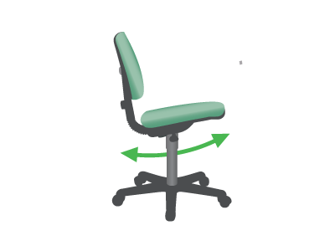

Seat angle tilt adjustment
Allows the seat to tilt forward to rotate the pelvis.
When you stand up your pelvis rotates forward. This posture produces the least amount of stress on muscles, tendons and discs whilst upright. It also pulls the chest out, increases lung capacity and facilitates breathing as well as improving the working of the heart and blood circulation. Furthermore, it allows you an open abdomen, which aids digestion.
When your pelvis is tilted forward your lumbar spine curves naturally and the rest of your spine follows.
This posture should be adopted when working upright or forward. The backward seat tilt can be used in conjunction with the backrest tilt to relax the spine and take some pressure off discs and muscles.
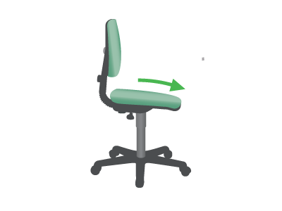

Seat

Height adjustable seat
Allows you to adjust the chair so that feet are firmly on the floor or footrest.
Also ensures that keyboard/work surface are at an appropriate height.
In a perfect world you should be able to achieve both without a footrest. A height adjustable desk may be part of this ideal solution.
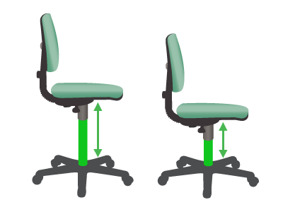

Seat depth adjustment
Allows you to adjust the seat depth by moving the seat or backrest in and out.
When seated you need to be fully supported by the backrest.
If you are short in the thigh you will need to reduce the seat depth so that you can reach the backrest and reduce pressure on the back of your thighs. Shorter people often perch on the front of the seat, getting no support from the backrest, compromising their natural posture and causing their muscles to overwork.
If you are long in the thigh, seat depth adjustment will allow you to support your thighs correctly.
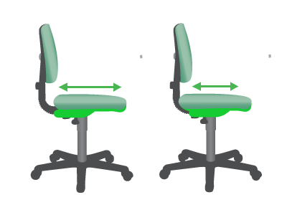

Backrest

Backrest angle adjustment
Changes the angle of the backrest relative to the seat.
Reclining the backrest whilst not working forward (keying or writing) allows the backrest to take some of the weight of your upper body. This in turn reduces the pressure on discs and muscles.
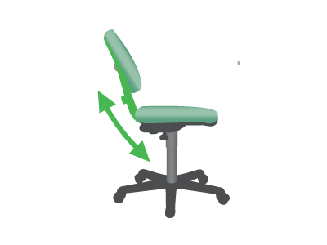

Armrests

Height adjustable armrests
Allows the vertical height of the armrests to be adjusted.
Supports the weight of your arms, removing the muscle work for shoulders and upper arms.
Armrests can be of particular benefit for support when keying or mousing. However, if they are not adjustable they can cause problems when armrests hit the edges of tables, causing users to key/mouse with a straight arm or perch on the front of the chair receiving no back support.
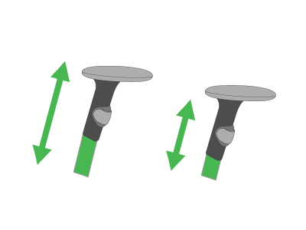

Width adjustable armrests
Allows you to position the armrest the correct distance from your body.
Armrests that are close to the body can help avoid splayed elbows, which in turn cause the wrists to bend to the side during activities such as keying.
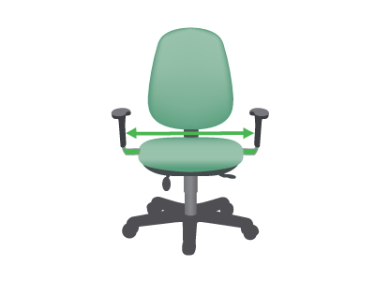

Padded armrests
Avoid uncomfortable pressure on the undersides of the forearms and elbows.
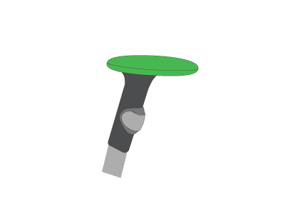

Lumbar

Lumbar support
Gentle curves in the backrest shape or inserts into the body of the backrest.
Lumbar support is intended to avoid flattening of the lumbar spine that can occur when seated and is used best in conjunction with a tilting seat.
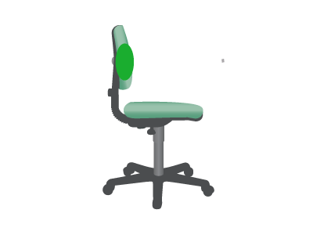

Lumbar pump depth adjustment
Allows the depth and sometimes the firmness of the lumbar support curve to be adjusted.
This best accommodates different preferences and body shapes.
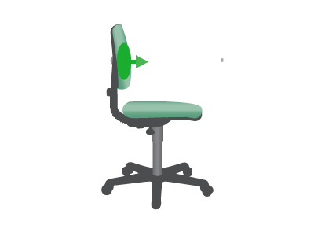

Lumbar height adjustment
Changes the height of the lumbar support area of the chair backrest.
This feature accommodates preferences by different workers regarding where the lumbar support curve contacts the back.
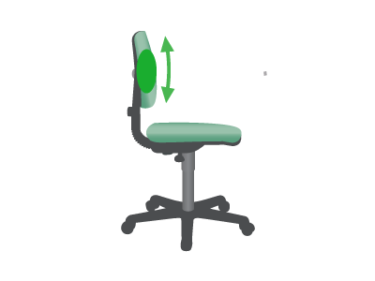

Headrest

Headrest height
Changes the height of the headrest to provide ergonomic support.
Particularly helpful for people with neck and shoulder problems, and they allow the muscles in this area to relax, thereby increasing the blood flow.
The ergonomic chair headrest is normally only used when slightly reclined.
