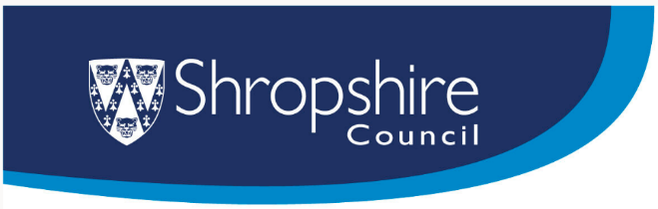

Sharps, syringes and illegal drugs
Procedure for public buildings and outdoor spaces under Council control.
Contents:
1. Statement of purpose/objectives
2. Scope
3. Assessment of Sharps exposure
4. Control of sharps
5. Information, instruction and training
6. Implementation
7. Review of procedure
1. Statement of purpose/objectives
This procedure will assist Shropshire Council in caring for staff and complying with the law.
2. Scope
This procedure applies to all Shropshire Council employees including part time, temporary staff and volunteers, who deal with sharps (i.e. needles, scalpels, other items that can cut, prick or cause injury), syringes and illegal drugs that have been inappropriately left within or around premises and outdoor spaces under Council control.
3. Assessment of sharps, syringe and illegal drug exposure
Shropshire Council has a duty to ensure that an assessment of the risk from sharps, syringes and drugs to the health and safety of employees is undertaken by a competent person. It does not need to be a separate risk assessment but can be included in the general risk assessment for the service or premise. The assessment should enable managers to decide how to control the risks associated with these items. It should be reviewed when it is no longer valid, and a record of the risk assessment should be kept.
4. Control of sharps and associated items such as syringes and illegal drugs.
The risk from exposure to these items will be reduced to as low as is reasonably practicable.

5. Information, instruction and training
The Council will provide adequate information, instruction and training to employees about their likely sharps and syringes exposure, the risk to their health and what is to be done to control risks.
6. Implementation
Management guidance in the form of Frequently Asked Questions is provided.
7. Review of procedure
Line Managers are responsible for ensuring that safe procedures are being adopted. A periodic review will be conducted by the Health and Safety Team.
Approving Body
Health, Safety & Welfare Group – Nov 2024
Revised by H&S Team – June 2026

Sharps and syringes - Procedure for public buildings and outdoor spaces under Council control.
Frequently Asked Questions

Contents:

- Roles and responsibilities/who does what?
- Do I have to have a written risk assessment for control of sharps?
- What training is available?
- How should I handle sharps and syringes?
- How should I dispose of used sharps and syringes?
- How should I dispose of illegal drugs?
- How do I dispose of the nitrile gloves?
- What do I do with the tongs?
- How do I dispose of a full sharps bin?
- What should I do if I injure myself with a used needle or sharp?
- What about sharps, syringes or drugs left in public spaces not in the Premises or Outdoor Spaces control?

1 | Roles and responsibilities/who does what?
 | The Organisation - Specific Responsibilities document sets out the roles and responsibilities with respect to health and safety for all levels of staff within the Council. This document forms part of the Council’s Health and Safety Policy and can be found here: Health and safety policy
2 | Should a written risk assessment for control of sharps, syringes and drugs be carried out?
If there is a foreseeable risk of sharps and syringes being inappropriately left within or around our premises, or in our outdoor spaces, then a risk assessment must be written. It does not have to be a standalone assessment. It can be recorded as part of the general risk assessment for the workplace or work activity.

The assessment should specify who is authorised to remove such items and how this should be done, including the equipment and PPE to be used and the training to be given. Under no circumstances should staff attempt to remove such items without the training, equipment and PPE to do so safely.

As with all risk assessments, staff must read it through and sign to say they have read and understood the controls to be followed.

For small quantities of sharps, syringes and illegal drugs it is appropriate, for willing, trained staff to remove the contaminated items using the correct equipment and PPE (as specified below in Q3 to Q7).

For large quantities of contaminated items, the manager must decide whether it is safer to contract a company to remove the items. Companies such as Busy Bee Cleaning on 01952 255222 or Vortex 01952 769073 can provide this service. The Health and Safety team can be consulted for advice in this instance if managers are unsure: health.safety@shropshire.gov.uk or 01743 252819.

For any quantity of sharps, syringes and other drugs paraphernalia the area concerned should be sealed off or warning signs put up until the items can be cleared.

3 | What training is available?
 | A training course is available on Leap into Learning – “Sharps awareness in the workplace”. Staff who may be involved in clearing away sharps should complete this training.
4 | How should I handle sharps, syringes and illegals drugs?
Sharps (i.e. needles, scalpels, other items that can cut, prick or cause injury) can cause injuries, sometimes known as needle-stick injuries. Used needles and syringes can carry blood-borne viruses that may be passed on to other people.

It is important that staff avoid direct contact with sharps and syringes by wearing disposable nitrile gloves and, if preferred, using a pair of tongs when picking up these items, as shown below:

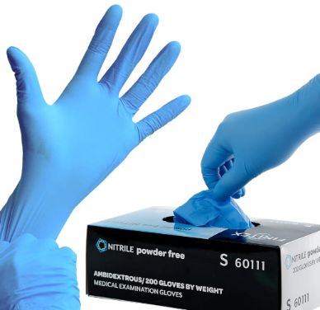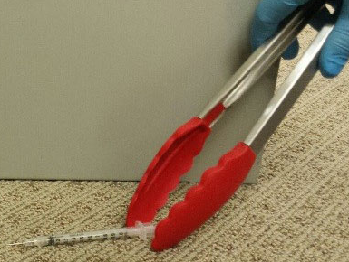

Tongs must be used if items cannot be picked up without the risk of sustaining a needlestick injury or if checking an area, e.g. floors or furniture, for sharps where any items present cannot be clearly seen.

When disposing of illegal drugs, it is also a good idea to wear these gloves.

5 | How should I dispose of sharps and syringes?
Do not put used sharps, needles or syringes in:

- any type of general rubbish or recycling bin

- a container that's no longer needed, such as a drinks can or bottle.

A sharps bin must be used to dispose of needles and syringes. This is a specially designed box with a lid, available in various sizes to suit your requirements, see examples below:
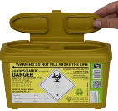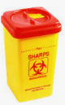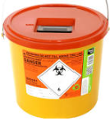
All Premises/Services where there is a foreseeable risk of sharps and syringes being inappropriately left by members of the public should have a sharps bin available. The Council does not have a preferred supplier, but bins can be purchased on-line.
Keep your sharps bin in a safe place so it's not a risk to other people and is out of the sight and reach of children.
6 | How should I dispose of illegal drugs?
If illegal drugs are found, a report should be made to the Police via the 101 telephone or online report line Contact us | Police.uk or by contacting the local Community Support Officers.

Small packets of drugs can be disposed of by flushing the contents down the toilet and the packet can be disposed of in a normal waste bin, preferably one with a swing lid and in a location not in a publicly accessible area.

It is recommended that nitrile gloves are worn when dealing with packets of drugs. The drugs packet can be folded inside the nitrile gloves as the gloves are removed and disposed of as described above.

7 | How do I dispose of the nitrile gloves?
When removing them from your hands, take hold of the cuff and pull off your hand (they will turn inside out, as you pull them off). See below. Place the gloves in the normal waste bin and wash your hands thoroughly.

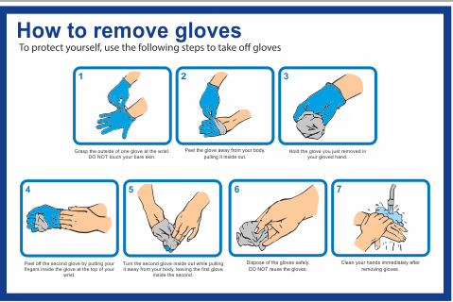

8 | What do I do with the tongs?
 | It is recommended that tongs, that could be contaminated, are kept in a bucket or similar and clearly labelled, ready for the next use. Keep this near your sharps bin and in a safe place so it's not a risk to other people and is out of the sight and reach of children. This container should not be used for any other purpose.
9 | How do I dispose of a full sharps bin?
All bins show a line above which they must not be filled – see example below:
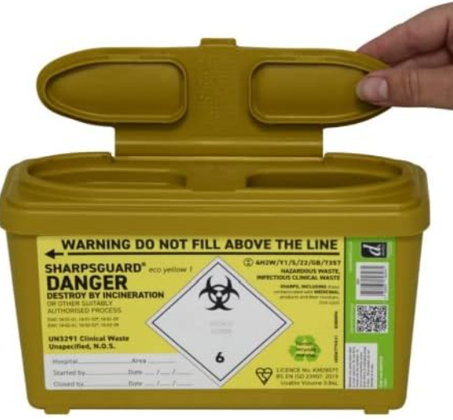

The bin can be used until it is full to the line. Do not close the lid in between uses. Once the bin is full, close the lid firmly and complete the details on the label.

Small bins can often be disposed of via a GP surgery. If this is not possible, or for larger quantities contact Busy Bee Cleaning on 01952 255222 or Vortex 01952 769073. These companies will make a charge to collect the bin. This will be payable by the Council Service involved.

10 | What should I do if I injure myself with a sharp?
If you pierce or puncture your skin with a sharp, follow this first aid advice immediately:
- encourage the wound to bleed, ideally by holding it under running water;
- wash the wound using running water and plenty of soap;
- do not scrub the wound while you're washing it;
- do not suck the wound;
- dry the wound and cover it with a waterproof plaster or dressing.

You should also seek urgent medical advice as you may need treatment to reduce the risk of getting an infection:
- call your GP, NHS 111 or go to the nearest accident and emergency (A&E) department

Further actions required are:
- inform your Line Manager straight away and report the incident on ERP;
- your Line Manager should review the risk assessment and controls in place.

11 | What about sharps, syringes and illegal drugs left in public spaces such as pavements, verges, highways not under the Council’s control?
Along with broken glass, offensive graffiti and hazardous waste, syringes and drug related litter should be reported to the street cleaning team via Tel: 0345 678 9006.

Lower priority street cleaning needs such as general litter, fly posting, inoffensive graffiti and urination should be reported on FixMyStreet (shropshire.gov.uk).

